Section 2.3 Math Link
This worksheet will help you with the Math Link on page 71.

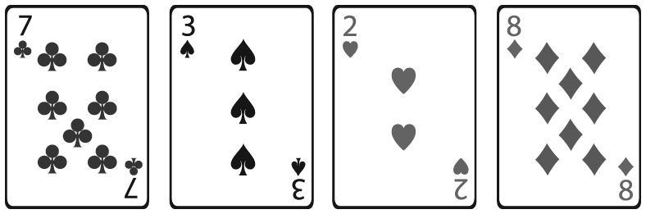
During the game described in the Math Link,
the following four cards were dealt:

The heart and the diamond are positive values, and the club and the spade are negative values.

1. Use the cards to create products of fractions.
• Estimate.
• Then, calculate.
Record these products in the table. An example is provided.
Product | Estimate | Calculation
2. Identify the product that is furthest from zero. ____
3. List any patterns you see in the table.
4. Was it necessary to list all possible products to determine the product furthest from zero? Why or why not?

