Section 2.4 Math Link
This worksheet will help you with the Math Link on page 81.
One example of a 9-by-9 square grid used in sudoku is given below. The smallest squares on the grid have a side length of 1.1 cm.

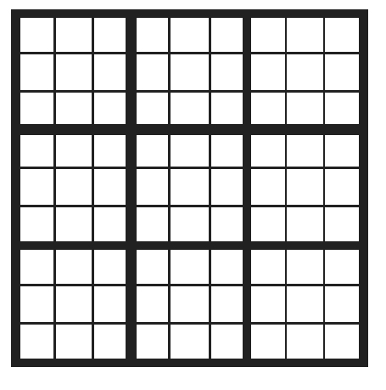
1. Follow the steps to determine the area of the 9-by-9 grid.
a) Each 3-by-3 section has ____ small squares.
b) The area of each small square = ____ × ____ = ____ cm².
c) The area of the 3-by-3 section is ____ × ____ = ____ cm².
d) The 9-by-9 grid has ____ 3-by-3 sections.
e) The area of the 9-by-9 grid is ____ × ____ = ____ cm².

2. Follow the steps to determine the area of the 9-by-9 grid in another way.
a) The number of small squares in the 9-by-9 grid is ____.
b) Using your answers from #1b) and 2a), determine the area of the entire grid. ____ × ____ = ____ cm²
c) Compare this answer to the answer for #1e).

3. A 9-by-9 sudoku grid has an area of 182.25 cm². Follow the steps to determine the dimensions of each 3-by-3 section.
a) The number of 3-by-3 sections in the 9-by-9 grid is ____.
b) The area of each 3-by-3 section is ____ ÷ ____ = ____ cm².
c) The side length of each 3-by-3 section is = ____ cm.
d) The dimensions of each 3-by-3 section are ____ cm × ____ cm.

4. Follow the steps to determine the dimensions of each 3-by-3 section in another way.
a) The side length of the 9-by-9 grid is = ____ cm.
b) The number of 3-by-3 sections along one side of the 9-by-9 grid is ____.
c) The side length of each 3-by-3 section is ____ ÷ ____ = ____ cm.
d) The dimensions of each 3-by-3 section are ____ cm × ____ cm.

