Chapter 2 BLM Answers

BLM 2–1 Chapter 2 Math Link Introduction
1. a) 32 b) 9 cm² c) 32 × 9 = 288 cm²
2. a) 8 b) 32 c) = 4 cm
3. a) Diagram should show a square with a diagonal line from one corner to the opposite corner.
b) 32² + 32² = c²
2048 = c²
c = 45.3 cm
BLM 2–2 Chapter 2 Get Ready
1. a) 152.85714 b) 272.430 c) 390.16600
d) 3.2020202
2. It is less than since we are multiplying by a number less than 1.
3. The answer will be greater than 3 since we are dividing by a number less than 16.
4. a) , 0.75 b) , 0.4 c) or , 0.25
5. a) , b) , ,
6. a) + b) –
7. a) b) c) d)
8. a) b) c)
9. a) b) c) d) or
BLM 2–3 Chapter 2 Warm-Up
Section 2.1
3. Three; 120° or of a turn
4. 571.2 cm²
5. Side view:
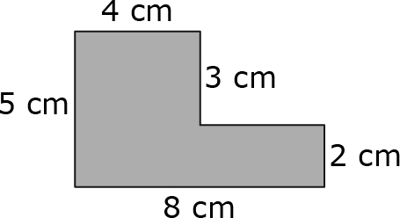
Top view:
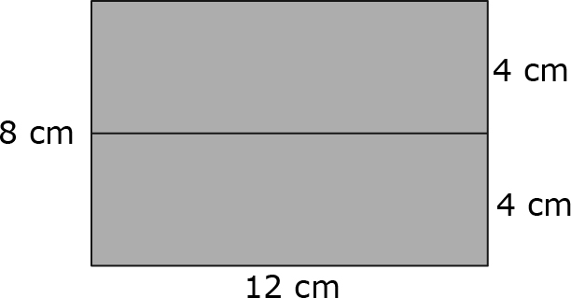

Front view:
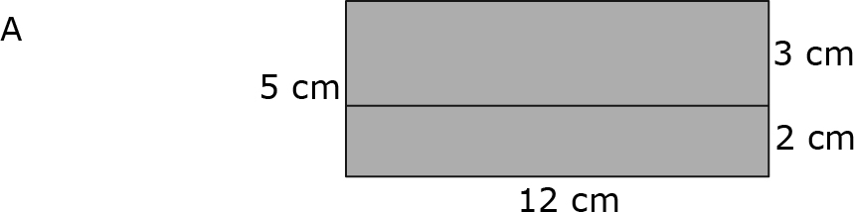
6. =
7.
8. Examples: , ,
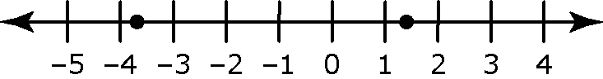
9.

10. Example: On a number line, –8 is farther left and therefore smaller than –5.

Section 2.2

1. The leaf without the stem appears to be rotating through the same-sized angle.
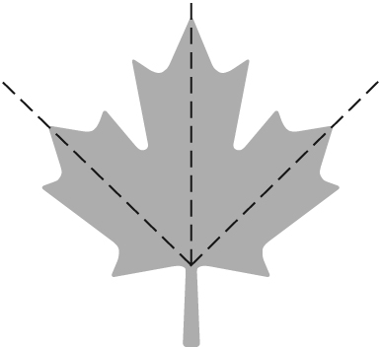

2. You are covering 2 cm² because you are covering the 1 cm² surface on your fingertip and the 1 cm² surface on the tabletop.
3. –3.7
4. –2, 1, 0, 1, 2, 3, 4, 5
5. Example:
6. –18 7. +3 8. +120 9. –8 10. 0.4

Section 2.3
1. 2. 3. Example: Approximately –12
4. –4.36 + 1.2[2.8 + (–3.5)] = –4.36 + 1.2 (–0.7)
= –4.36 + (–0.84)
= –5.2
5. –2.2 °C 6. = 1 7. =
8. = 9. = 7
10. You have six tickets left to sell.

BLM 2–4 Chapter 2 Problems of the Week
1. Example:
45 min | 30 min | 15 min | 20 min | 5 min
2. Example: The pattern lies in the Pythagorean relationship. For example, 3² + 4² = 5², so the 3, 4, 5 triangle (or any triangle similar to it) is easy to solve without a calculator.
3. Solution: : = : = 3 : 8 = . Therefore, of the gold bar should be cut off.
4. a) Length of diagonals from least to greatest:
, , , , , , , , , , , , , , , , , , , ,
b) or : = 5; or : or 10
BLM 2–5 Section 2.1 Extra Practice
1. a) 17, –3.606, b) –0.2, , ,
2. a) –9 b) c) 17.6 d) e) –401
f)
3. A B −2.1 C −0.3 D E F
4. , , –0.6, , 1.7
5. 1.9, , , –0.5,
6. b), c)
7. a), b)
8. a) b) c) d) e)
f)
9. a) i) 0.25, 0.5 ii) Example: 0.4
b) i) –0.4, –0.6
ii) Example: –0.5
c) i) –0.1, –0.125 ii) Example: –0.11
d) i) , ii) Example: –0.7
e) i) –1.75, –1.8 ii) Example: –1.76
f) i) –1.95, –2.0 ii) Example; –1.96
10. a) i) , ii) Example: =
b) i) , ii) Example:
c) i) , ii) Example: =
11. a) = b) =
c) =
12. 5, 4, 3, 2, 1, 0, –1, –2, –3, –4
BLM 2–6 Section 2.1 Math Link
1. D, A, C, B
b) A c) d)
e) is closer to zero. Example: is the same as , is the same as , and is further to the left on the number line
than .
2. a) b) c) d)
BLM 2–7 Section 2.2 Extra Practice
1. a) i) Example: 1 + (–3) = –2 ii) –2.58
b) i) Example: –7 + –8 = – 15 ii) –14.92
c) i) Example: 8 – 5 = 3 ii) 2.45
d) i) Example: –3 + 4 = 1 ii) 1.38
e) i) Example: –1 + 2 = 1 ii) 1.241
f) i) Example: 0.5 + 0.1 = 0.6 ii) 0.675
2. a) i) Example: –4 × 7 = –28 ii) –27.3
b) i) Example: –5 × (–9) = 45 ii) 47.43
c) i) Example: –2 ÷ (–1) = 2 ii) 1.2
d) i) Example: 36 ÷ (–4) = –9 ii) –8.5
e) i) Example: 3 × (–4) = –12 ii) –11.34
f) i) Example: –9 ÷ (–0.3) = 30 ii) 26.758
g) i) Example: –6 ÷ 20 = –0.3 ii) –0.273
h) i) Example: –0.3 × (–0.9) = 0.27 ii) 0.264
3. a) i) Example: –6 + (–1) ÷ (–1 + 0) = –5
ii) –5.4
b) i) Example: –2 × (–3) + (–1) × 2 = 4
ii) 5.016
c) i) Example: –6 × (–4) – 1 ÷ 0.5 = 22
ii) 24.04
4. a) 135.25 + (–159.15) = –23.90
b) Camille’s account balance is –$23.90.
5. a) (–12) + (+4) + (–11) + (+9) + (–3) = –13 b) The temperature on Friday was –13 °C.
6. a) 126(2.00) – (130)(1.45) = 63.50
b) The student council earned $63.50 on their birthday card sale.
7. a) 45 – (–63) = 108
b) The difference between the hottest day and coldest day in Canada is 108 °C.
8. a) i) 5.8 – (–8.1) = 13.9 ii) –8.1, –3.2, –0.5, 0.6, 1.8, 2.5, 5.8; median: 0.6 iii) –8.1 + (–3.2) + (–0.5) + 0.6 + 1.8 + 2.5 + 5.8 = –1.1; –1.1 ÷

7 ≈ – 0.16 b) i) 14.2 – (–13.7) = 27.9
ii) –13.7, –7.3, 0, 4.1, 9.1, 12.3, 14.2; median: 4.1 iii) –13.7 + (–7.3) + 0 + 4.1 + 9.1 + 12.3 + 14.2 = 18.7; 18.7 ÷ 7 ≈ 2.67
BLM 2–8 Section 2.2 Math Link
1. Example: Estimate: –2, –4, –1, –5. Sum closest to zero: –2.6 + 2.1 ≈ –1. Verification:
–2.6 + 2.1 = –0.5
2. Example: Estimate: –4, –3, –2, –3. Sum closest to zero: –4.6 + 3.1 ≈ –2. Verification:
–4.6 + 3.1 = –1.5
3. Example: Estimate: –3, –2, –3, –2. Sum closest to zero: 3.2 + (–4.5) ≈ –2 or 3.2 + (–5.4) ≈ –2 but 3.2 + (–5.4) would be further left on the number line so choose 3.2 + (–4.5). Verification: 3.2 + (–4.5) = –1.3
BLM 2–9 Section 2.3 Extra Practice
1. a) i) Example: + 0 = ii)
b) i) Example: + 1 = ii)
c) i) Example: 4 + (–2) = 2 ii)
d) i) Example: – = 1 ii)
e) i) Example: –1 + = ii)
f) i) Example: + (–2) = –2 ii)
g) i) Example: + = –2 ii)
h) i) Example: – (–1) = ii)
2. a) i) Example: × (–1) = ii)
b) i) Example: 2 × 4 = 8 ii)
c) i) Example: 5 ÷ (–3) = ii) –2
d) i) Example: –1 ÷ = 2 ii)
e) i) Example:–1 × = ii)
f) i) Example: 0 ÷ = 0 ii)
g) i) Example: ÷ (–1) = ii)
h) i) Example: 1 × = ii)
3. a) Example:
b) Mark has 5 left to deliver.
4. a) Examples:
= –5300,
6000 + (–5300) = 700; 6000 + (–5300) = 700.
b) The Rodriguez family has $700 left for other expenses.
5. a) – = b) – =
c) ÷ = d) × =
BLM 2–10 Section 2.3 Math Link
1.
Product | Estimate | Calculation
× | 4 × 2 = 8 | =
× | –2 × (–1) = 2 | =
× | –3 × (–3) = 9 | =
2. Example: × =
3. Example: Only six numbers appear in the numerator or denominator: –56, –24, –14, –6, 16, 21.
4. Example: No, it is only necessary to determine the products of fractions that have greater values in the numerator than in the denominator.
BLM 2–11 Section 2.4 Extra Practice
1. a) i) Example: 16, 25, 19 ii) 19.36
b) i) Example: 121, 144, 136 ii) 136.89
c) i) Example: 0.49, 0.64, 0.6 ii) 0.6084
d) i) Example: 10² = 100, 11² = 121,
10.3² ≈ 106 ii) 106.09
2. a) i) Example: 4, 9, 5, 5 cm²
ii) 5.29, 5.29 cm²
b) i) Example: 64, 81, 79, 79 m²
ii) 79.21, 79.21 m²
c) i) Example: 0.25, 0.36, 0.27, 0.27 mm²
ii) 0.2704, 0.2704 mm²
d) i) Example: 0.0064, 0.0081, 0.007, 0.007 km²
ii) 0.007396, 0.007396 km²
3. a) No b) Yes, × c) Yes, ×
d) Yes, 0.9 × 0.9 e) No f) Yes, 1.2 × 1.2
g) Yes, 0.01 × 0.01 h) Yes, ×
4. a) 16 × 16 = 256, 16 b) 1.9 × 1.9 = 3.61, 1.9 c) 35 × 35 = 1225, 35
d) 0.22 × 0.22 = 0.0484, 0.22

5. a) 1.1 × 1.1 = 1.21, 1.1 cm
b) 25 × 25 = 625, 25 m c) 0.3 × 0.3 = 0.09, 0.3 mm d) 0.6 × 0.6 = 0.36, 0.6 km
6. a) i) Example: = 9, = 10,
≈ 9.1 ii) 9.1
b) i) Example: = 2, = 2.5,
≈ 2.4 ii) 2.37
c) i) Example: = 0.9, = 1,
≈ 0.96 ii) 0.954
7. ≈ 71. The lot’s dimensions are 71 m by 71 m.
8. 9² = 81, = 3, 81 – 3 = 78. The difference between the square of 9 and the square root of 9 is 78.
BLM 2–12 Section 2.4 Math Link
1. a) 9 b) 1.1 × 1.1 = 1.21 cm²
c) 9 × 1.21 = 10.89 cm² d) 9
e) 9 × 10.89 = 98.01 cm²
2. a) 81 b) 81 × 1.21 = 98. 01 cm²
c) The answers are the same.
3. a) 9 b) 182.25 ÷ 9 = 20.25 cm²
c) = 4.5 cm d) 4.5 cm × 4.5 cm
4. a) = 13.5 cm b) 3
c) 13.5 ÷ 3 = 4.5 d) 4.5 cm × 4.5 cm
BLM 2–13 Chapter 2 Test
1. A 2. B 3. A 4. D
5. 0.7, 0.8 6. 7.4 7. a) 0.6 b) 8.0
8. a) b) 9. 4 and 5 10. 5.29 11. ≈ 3.2
12. Should be A, not 2A. s = 15
13. a) m b) m by m c) m

