Chapter 3 Math Link Introduction
This worksheet will help you with the Math Link introduction on page 91.

1. Fill in the table.

Diagram of Shape | Name of Shape | Formula for Perimeter/  Circumference | Formula for Area

a)

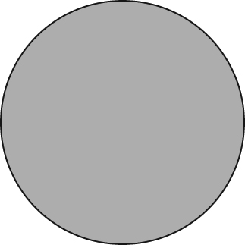
b)


c)

2. Match each solid to the statement that best describes it.
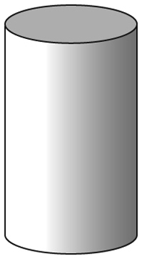  Cylinder | a) This shape has squares for all its faces.
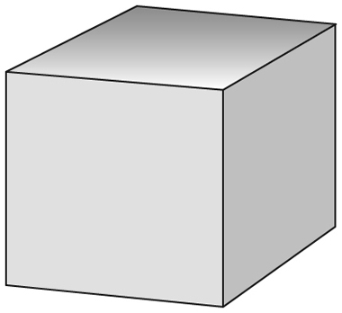  Cube | b) This shape has circles on both ends.
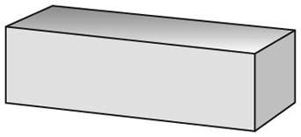  rectangular prism | c) This shape has both square and rectangular faces.
3. Imagine that each solid shown in the table is flattened out. For each solid, determine the following:
a) Identify the shapes that make up each face.
b) Write the formula(s) you would use to determine the area of each face. Use your table from #1.
c) Show how to calculate the surface area of each solid. Use your formulas from part b).

 | 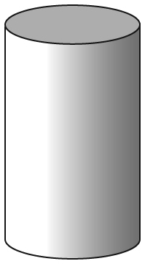 | 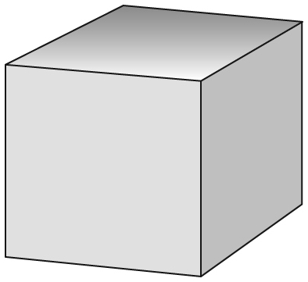 | 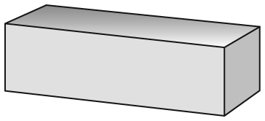
a) Shapes of Faces
b) Formula(s) for Area
c) Surface Area

4. To calculate the volume of a solid, multiply the area of the base by the height of the solid. Use this idea to write the formula for each of the following solids.
a) cylinder b) cube c) rectangular prism

5. a) How is calculating the surface area and calculating the volume of the
solids in #4 similar?
b) How is it different?

6. a) Which shapes would you use to put on a mobile?
b) Why did you choose these shapes?

