Section 3.1 Math Link
This worksheet will help you with the Math Link on page 98.

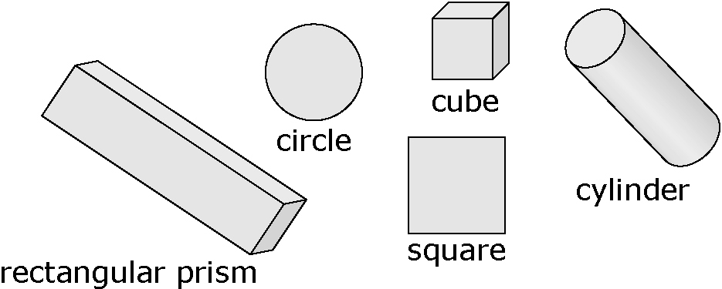

1. Fill in the blanks to rewrite each formula using repeated multiplication. Then, answer the questions.
a) S.A. = 6s²
S.A. = ____ × ____ × ____
What does S.A. stand for? ____________________
What solid is this formula used for? ____________________
Describe in words how you would use the formula S.A. = 6s².
___________________________________________________________
b) V = r²h
V = ____ × ____ × ____ × ____
What does V stand for? ____________________
What solid is this formula used for? ____________________
Describe in words how you would use the formula V = r²h.
___________________________________________________________
2. Fill in the blanks to rewrite each formula using repeated multiplication. Then, answer the question.
a) s² = ____ × ____
What shape or solid is this formula used for? ____________________
b) r² = ____ × ____ × ____
What shape or solid is this formula used for? ____________________
c) 2s² × h = ____ × ____ × ____ × ____
What shape or solid is this formula used for? ____________________

