Section 3.3 Math Link
This worksheet will help you with the Math Link on page 113.
The cube has a side length, s, of 10 cm. The cylinder has a height, h, of 10 cm and a radius, r, of 10 cm.

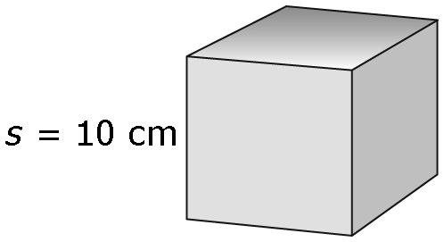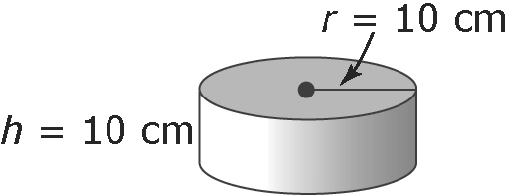
1. Follow the steps to calculate the surface area of each shape.
Cube
S.A. = 6 × area of one square face
S.A. = 6 × ____ × ____ Use the variable in the diagram.
S.A. = 6 × ____²
S.A. = 6 × ____² Substitute.
S.A. = ____ cm²
Cylinder
S.A. = 2 × area of circular end + area of rectangular wraparound
S.A. = 2 × × ____² + 2 × × ____ × ___ Use the variables in the diagrams.
S.A. = 2 × × ____² + 2 × × ____²
S.A. = 2 × × ____² + 2 × × ____² Substitute.
S.A. = ____ + ____
S.A. = _____ cm² Express to the nearest tenth of a square centimetre.
2. Determine the difference in the surface areas of the shapes.
Difference = surface area of ____________ – surface area of ____________
Difference = ____ – ____
Difference = ____ cm²
Which shape requires more material? ____________
How much more? ____ cm²
3. Determine the total surface area of the shapes.
Total = surface area of ____________ + surface area of ____________
Total = ____ + ____
Total = ____ cm²

