Section 3.4 Extra Practice
1. What is the volume of a cube with a side length of 4 cm? Show your work.
2. A colony of bacteria triples every hour. There are 30 bacteria now. How many will there be after each amount of time? Show your work.
a) 1 h b) 3 h c) 12 h d) n h
3. What is the surface area of a cube with a side length of 6 cm? Show your work.
4. Find the side length of the square attached to the hypotenuse in the diagram. Show your work.
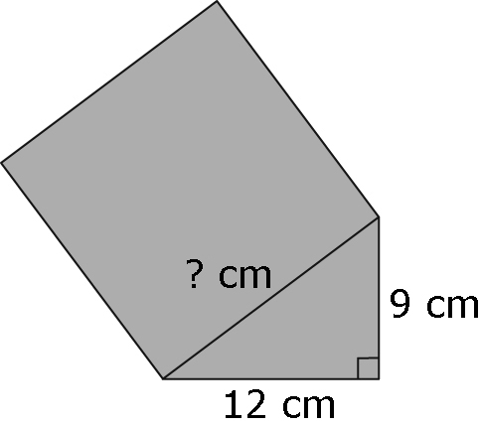
5. The diagram shows a circle inscribed in a square with a side length of 16 cm. What is the area of the shaded region? Give your answer to the nearest hundredth of a square centimetre. Show your work.
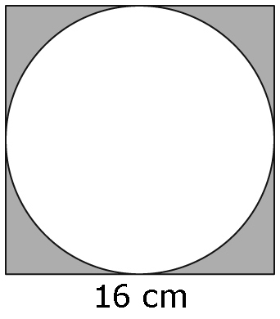
6. The combination for one type of bike lock has four numbers, from 0 to 9. The smallest combination is 0000, and the largest combination is 9999. How many number combinations are possible?
a) Express the answer as repeated multiplication and as a power.
b) Calculate the answer.
7. In the formula, d = 4.9t², d is the total distance, in metres, and t is the time, in seconds, that the skydiver free falls. Calculate the distance the skydiver falls in the following times. Show your work.
a) 2 s b) 4 s
8. A cylinder has a radius of 7 cm and a height of 12 cm. Calculate its surface area. Give your answer to the nearest hundredth of a square centimetre. Show your work.

