Chapter 4 Math Link Introduction
This worksheet will help you with the Math Link introduction on page 129.

Use the floor plan to answer the following questions.
• Express all actual lengths in centimetres.
• Calculate all areas in square centimetres.
• For #1 and 2, express answers to the nearest tenth.

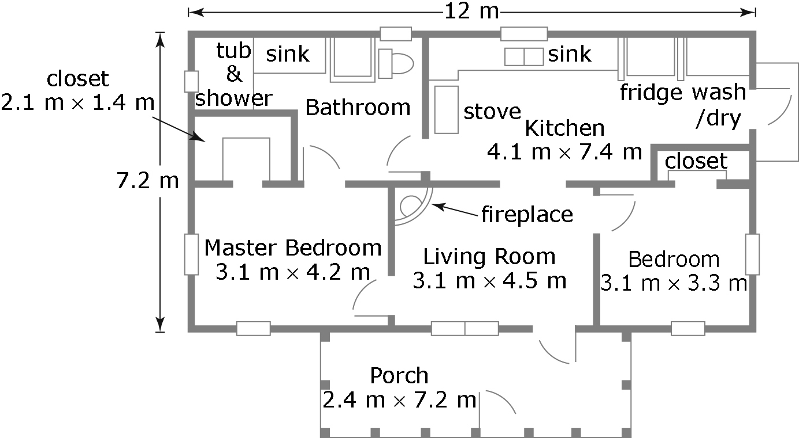

1. a) What is the area of the actual house? Include the porch.
Hint: Use the formula A = l × w.
 | House | Porch
Length | ____ m = ______ cm | ____ m = ____ cm
Width | ____ m = ____ cm | ____ m = ____ cm
Area | ________ cm² | ________ cm²
Total Area | __________ cm²
b) What is the area of the house on the blueprint? Hint: Use a ruler.
 | House | Porch
Length | ____ m = ____ cm | ____ m = ____ cm
Width | ____ m = ____ cm | ____ m = ____ cm
Area | ______ cm² | ____ cm²
Total Area | ______ cm²
2. a) What is the area of the actual living room?
Length = ____ m = ____ cm Width = ____ m = ____ cm
Area = ________ cm²
b) What is the area of the living room on the blueprint?
Length = ____ cm Width = ____ cm Area = ____ cm²
3. a) What is the ratio of the area of the actual house to the area of the blueprint house? Express your answer to the nearest thousand.
Note: A ratio compares quantities measured in the same units. Since each area is expressed in square centimetres, you can compare the areas.
b) What is the ratio of the area of the actual living room to the area of the blueprint living room?
c) Compare the two ratios. What can you conclude about the two ratios?
___________________________________________________________
d) What ratio do you expect for the areas of the actual and blueprint master bedrooms? Explain why.
___________________________________________________________
___________________________________________________________
4. a) Why do you think accuracy is important in developing a floor plan?
___________________________________________________________
b) Why is it important to keep the same proportions for the dimensions of an actual object and a drawing of the object?
___________________________________________________________
___________________________________________________________
5. Discuss with a partner two different examples in which ratios are used to compare objects in daily life. For example, you might consider how photographers and artists use ratios.

