Using Two-Term Ratios
A part-to-part ratio compares different parts of a group to each other.
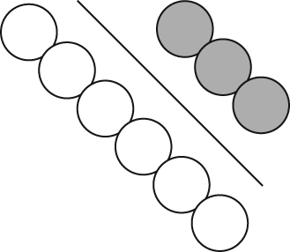
The ratio of white circles to grey circles is 6 : 3 or 6 to 3.
The ratio in lowest terms is 2 : 1 or 2 to 1.

A part-to-whole ratio compares one part of a group to the whole group.
The ratio of white circles to the total number of circles is 6 : 9 or 6 to 9.
The ratio in lowest terms is 2 : 3 or 2 to 3.
A part-to-whole ratio can be written as a fraction, a decimal, and a percent.
The ratio of .

1. For each regular polygon, what is the ratio of one side length to the perimeter? Use ratio notation.
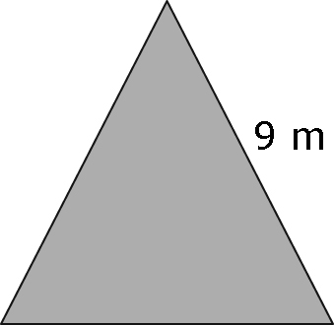
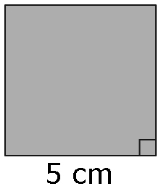
a) b)

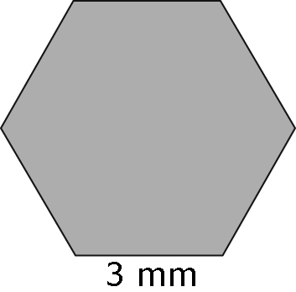
c)

2. Write each ratio in #1 as an equivalent ratio in lowest terms.
3. Write each ratio in #1 as a decimal and a percent.

4. Identify the missing value to make an equivalent fraction.
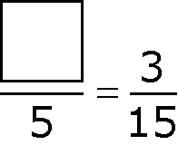
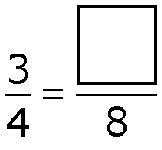
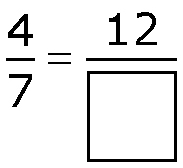
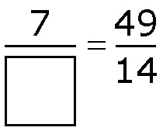
a) b) c) d)

Using Proportional Reasoning
A proportion is a relationship that says that two ratios are equal.
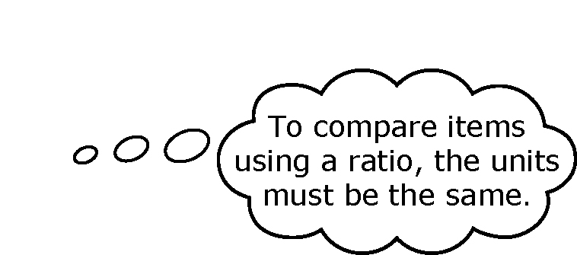
A proportion can be expressed in fraction form.
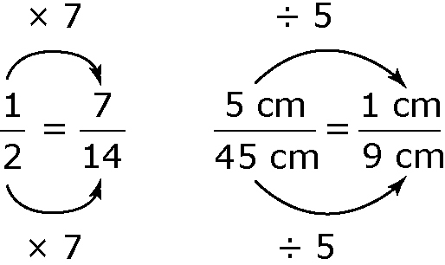

5. Set up a proportion for each situation.
a) On a diagram of a machine part, 2 cm represents 200 cm. The actual length of the part is 100 cm. This distance is 1 cm on the diagram.
b) On a map, 1 cm represents 500 m. Linda wants to ride her bike 3500 m. This distance is 7 cm on the map.
c) A diagram of a hot tub shows the actual 3-m length of one side of the hot tub as 15 cm. The 8-m length of the square deck around the hot tub is shown as 40 cm.
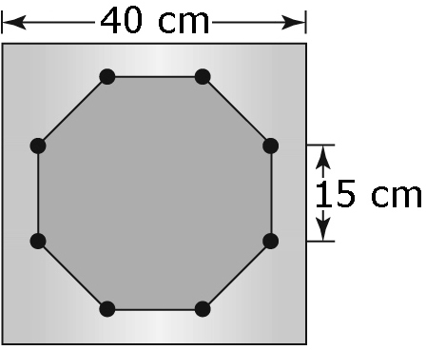

6. A telephone pole that is 12 m tall casts a shadow that is 2 m long. What is the length of the shadow cast by a student who is 1.5 m tall?
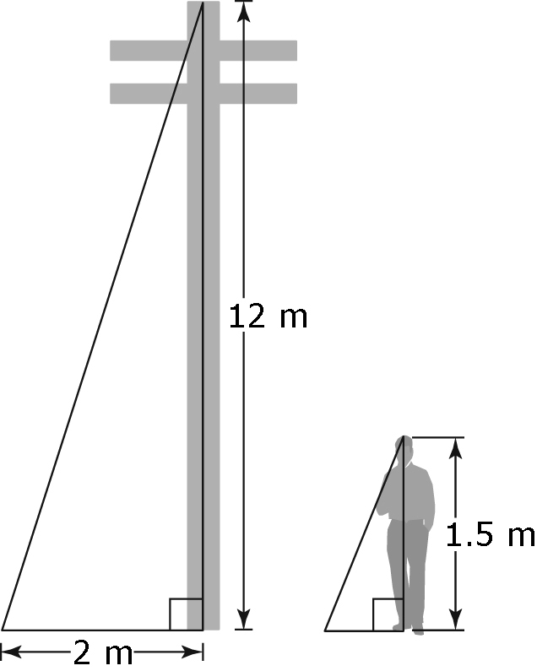
7. The distance between Town B and Town C is 56 km. The distance shown on the map is 7 cm in length. What is the actual distance between Town A and Town C if it is represented on the same map by a length of 12.5 cm?
