Section 4.2 Extra Practice
1. State whether you would multiply or divide to determine the missing value.
a) b) c) d)
2. Calculate the missing value in each proportion.
a) b) c)
d) e) f)

3. Calculate the actual length of each object.

a) The scale for the image of the scooter is 1 : 20.
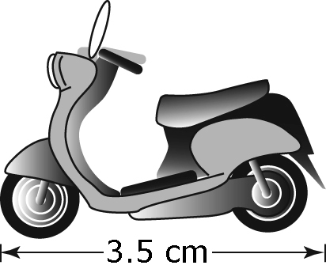
b) The scale for the enlarged image of a housefly is 1 : 0.3.
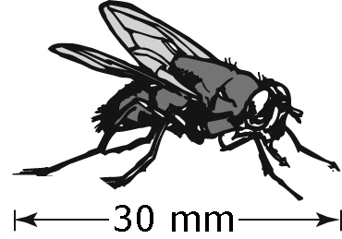

4. Determine the scale factor.

a) b) c)
d) e) f)

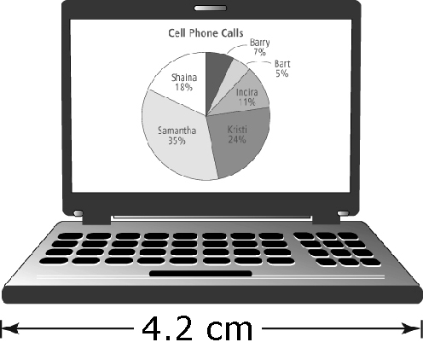
5. An actual laptop has a width of 39.5 cm.
Calculate the scale factor used in the image
of the laptop. Express the answer to the nearest tenth.

6. A driving distance is 650 km. The distance shown on a map is 4 cm.
a) Express the map scale in words.
b) What is the scale factor? Express the answer to the nearest tenth.

