Section 4.3 Extra Practice
1. List the corresponding angles and the corresponding sides in each pair of triangles.
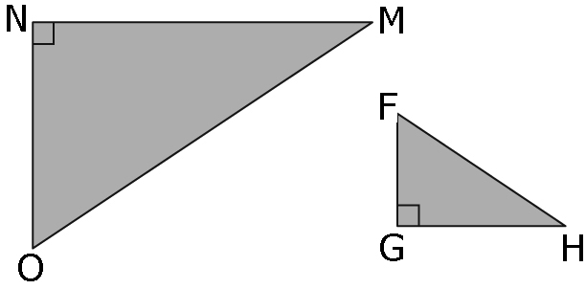
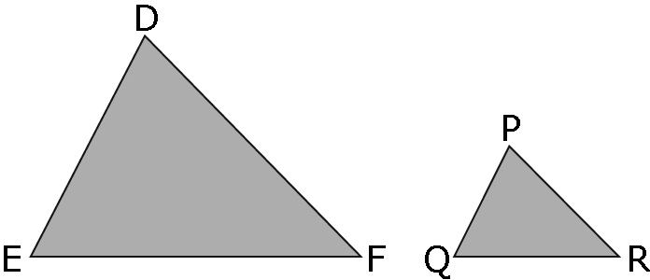
a) b)

2. Are the triangles similar? Show how you know.
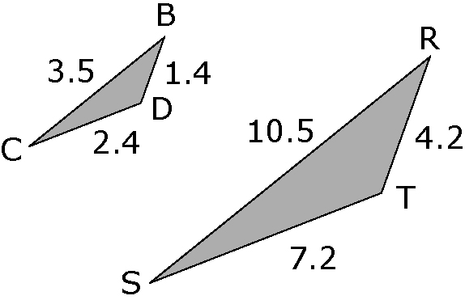

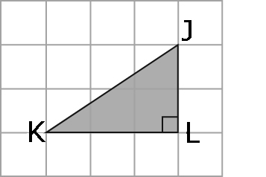
3. a) Use grid paper and a scale factor of
2 to draw WXY so that it is similar to JKL.
b) List the corresponding angles and
the corresponding sides.

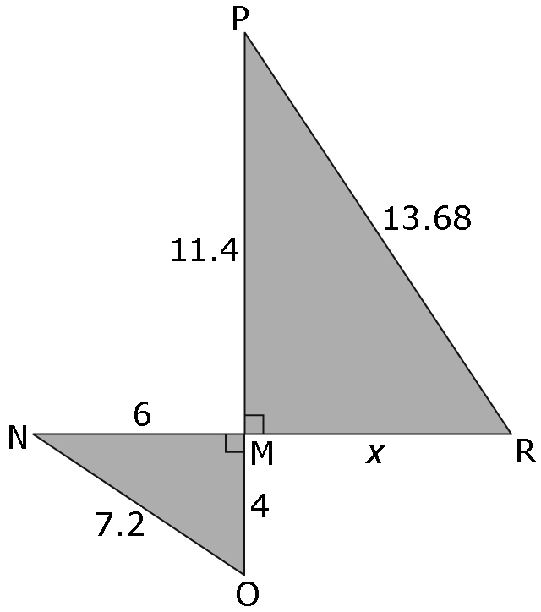
4. MNO is similar to MPR. Calculate the
missing length, x, to the nearest tenth.
Hint: Compare the corresponding sides
to determine the scale factor. Use the scale
factor to solve for the missing length.

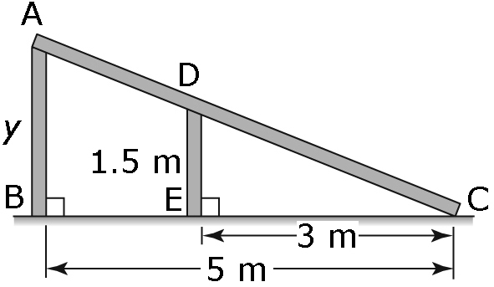
5. The two vertical supports on a ramp
form two triangles. ABC is similar to
DEC. Find the height of the ramp by
calculating the missing length, y.
Show your work.

