Section 4.3 Math Link
This worksheet will help you with the Math Link on page 153.

For your design project report, include a signature logo that features your name.
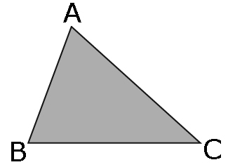
1. On a sheet of 8.5 × 11 paper,
design your logo. Include a triangle
that is similar to the one shown.

a) To help you draw a similar triangle, follow these steps.
• Measure all the angles of the triangle.
∠A = ____° ∠B = ____° ∠C = ____°
• Measure the side lengths of the triangle.
AB = ____ cm BC = ____ cm AC = ____ cm
• Decide on a scale factor. ____
• Use the scale factor to determine the lengths of your new triangle.
A'B'= ____ cm B'C' = ____ cm A'C'= ____ cm
• Draw your triangle.
Hint: Draw one side length. Create the appropriate angle on each end of the side length. Then, draw the remaining side lengths along the angle and according to the scale factor.
b) Show how you know that your triangle is similar to the one shown.

2. On grid paper, draw a scale diagram of the logo to fit on your design project. For example, you might make each side length of the triangle on your logo of the side length of the drawing you made above.
a) Will you enlarge or reduce your logo to fit on your design project? ______
b) Identify the scale factor you will use. ____
c) Using the scale factor, draw your logo.

