Section 4.4 Extra Practice
1. Decide if each pair of polygons is similar. Show your reasoning.
a) CDEF and RSTU are parallelograms.
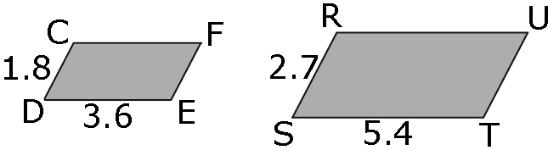

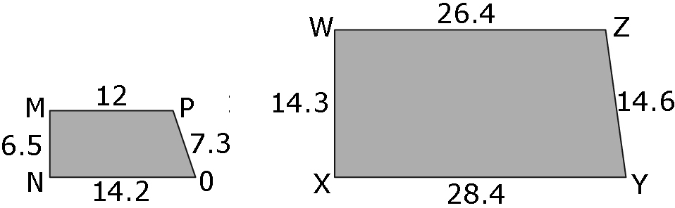
b)

2. The two pentagons DFHIJ and EFGLK are similar. Determine the missing length, x. Show your work.
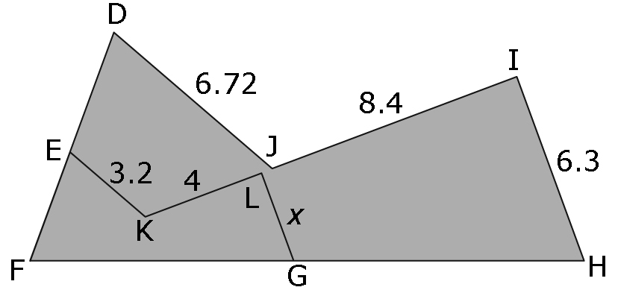

3. The trapezoid is a scale drawing of a cattle pasture. The actual length of the shortest side of the pasture is 200 m.
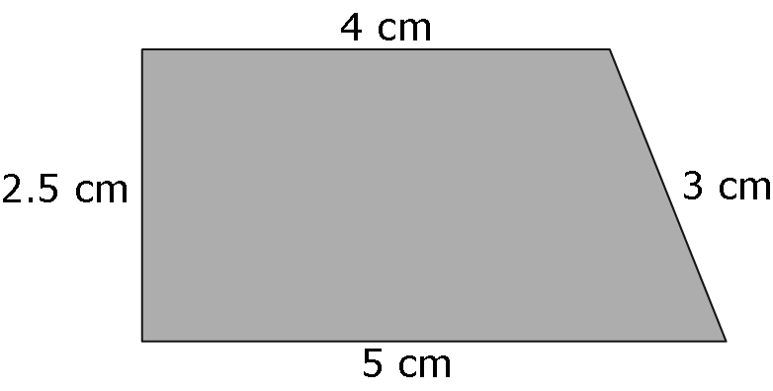
a) Use what you have learned about similar polygons to determine the actual length of the other sides of the pasture. Show your work.
Hint: 200 m = 20 000 cm

b) How long is the fence surrounding the pasture? Show your work.

