Section 4.4 Math Link
This worksheet will help you with the Math Link on page 159.

For your design project, include a polygon. Use a polygon that is similar to one shown here. The polygon will feature the title of your design project.

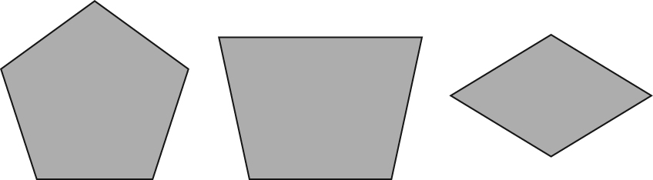

1. Use grid paper to copy the polygon you chose.

2. a) To help you draw a similar polygon, follow these steps.
• Measure all the angles of the polygon.
• Measure the side lengths of the polygon.
• Decide on an appropriate scale factor. ____
Hint: The title of your design project needs to fit inside the polygon.
• Use the scale factor to determine the lengths of your similar polygon.
b) Using the scale factor, draw your polygon on grid paper.
• Add the title of your design project.
• Label the scale factor on your design.

