Chapter 4 Test
For #1 to 4, choose the best answer.


1. Jason arranged shapes into sets of similar
polygons. How many of the shapes in the sets
do not appear to be similar to any other shape?
A 5 B 4 C 3 D 0

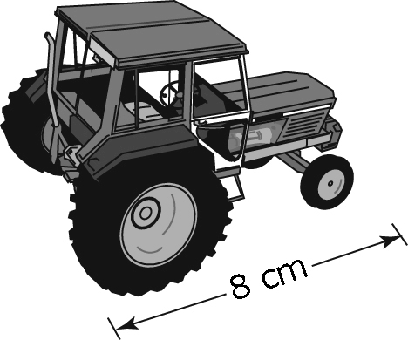
2. A local farm equipment dealership has model
tractors. The length of the actual tractor is 5.6 m.
What scale factor was used for the reduction?
A B 7 C 70 D 700

3. A penny has a diameter of 19 mm. Brenda used a scale factor of 3 to create a scale drawing of the penny. Which of the following statements about Brenda’s drawing is true?
A Brenda drew an enlargement. The drawing has a diameter of 57 mm.
B Brenda drew an enlargement. The drawing has a diameter of about
6.3 mm.
C Brenda drew a reduction. The drawing has a diameter of 57 mm.
D Brenda drew a reduction. The drawing has a diameter of about 6.3 mm.

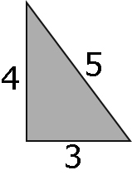
4. Which of the following triangles is similar to the given triangle?

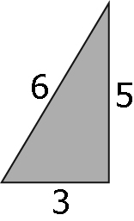
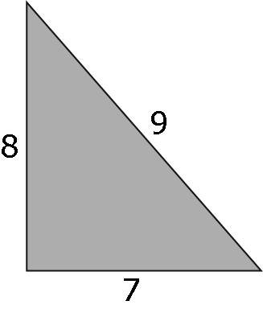
A B

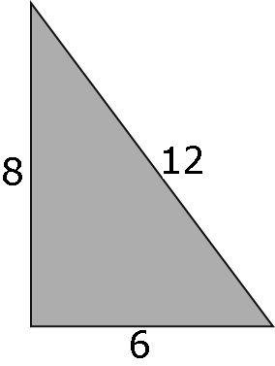
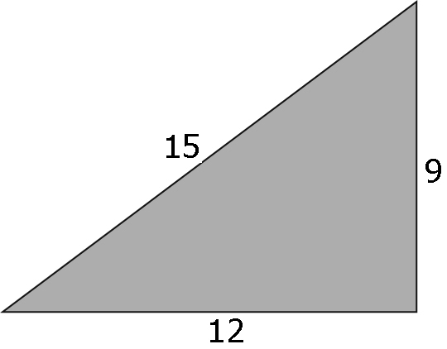
C D

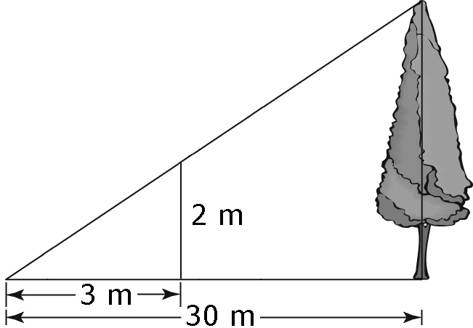
Complete the statements in #5 and 6.

5. Using the information given in the diagram, the
height of the actual tree is _____ m.

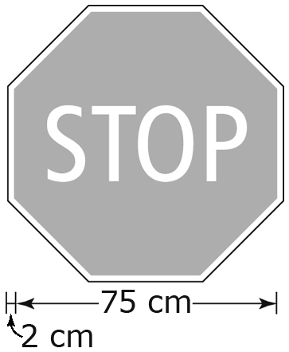
6. A standard stop sign is 75 cm across from one
side of the red octagon to the opposite side,
with a 2-cm white border. The letters forming
STOP are 25 cm tall. Using a scale of 14, the
entire width of an image of the stop sign
is _____ cm, to the nearest tenth of a centimetre.
Short Answer
7. Use a scale factor of 0.5 to draw a reduction of this figure.
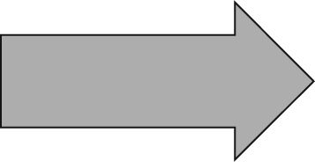

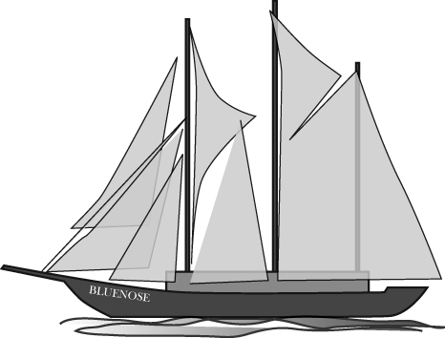
8. Raul’s grandfather collects models of ships such
as Bluenose. The model measures 120 mm in
length and the scale used to make the model is
1 : 470. Calculate the length of the actual
sailing ship to the nearest tenth of a metre.

Extended Response

9. Determine if the two triangles are similar. Show your work.
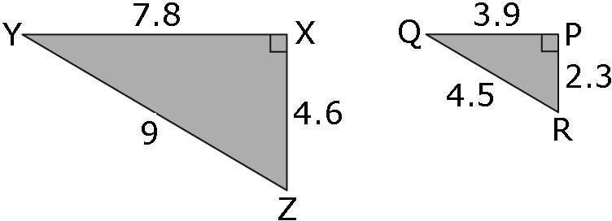

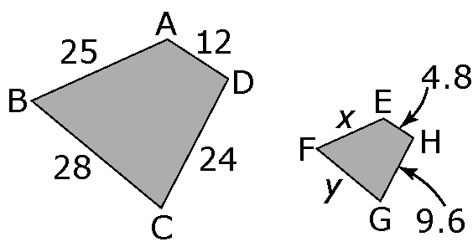
10. Use the two similar trapezoids to determine
the missing side lengths, x and y.
Show your work.

