Chapter 4 BLM Answers

BLM 4–1 Chapter 4 Math Link Introduction
1. a) Example: House: Length = 12 m, 1200 cm; Width = 7.2 m, 720 cm; Area = 864 000 cm².
Porch: Length = 7.2 m, 720 cm; Width = 2.4 m, 240 cm; Area = 172 800 cm²;
Total Area = 1 036 800 cm²
b) Example: House: Length = 8.3 cm;
Width = 4.4 cm; Area = 36.5 cm².
Porch: Length = 4.6 cm; Width = 1.6 cm;
Area = 7.4 cm²; Total Area = 43.9 cm²
2. a) Example: Length = 4.5 m, 450 cm; Width = 3.1 m, 310 cm; Area = 139 500 cm²
b) Example: Length = 2.9 cm; Width = 2 cm; Area = 5.8 cm²
3. a) Example:
= 23 617.3 cm² = 24 000 cm²
b) Example:
= 24 051.7 cm² = 24 000 cm²
Note that some students may express values for a) and b) in metres to 2.4 m².
c) The ratios are the same.
d) Example: The ratio for the area of the actual master bedroom and the drawing of the master bedroom should be the same as the other ratios. The image of the master bedroom was drawn to the same scale as the rest of the house.
4. a) Example: Accuracy is important so the proportions (e.g., area, length of walls) of each room remain the same in the drawing as in the actual house.
b) Example: Maintaining correct proportions is important to make conversion to actual measurements from the drawing easier.
5. Example:
• Artists use ratios to determine how large to make each facial feature in relation to the other features and how to align the features on the head for a portrait.
• Skiers use ratios to determine the correct length of skis for their height.
BLM 4–2 Chapter 4 Get Ready
1. a) 5 : 20 or 5 to 20 b) 9 : 27 or 9 to 27
c) 3 : 18 or 3 to 18
2. a) 1 : 4 or 1 to 4 b) 1 : 3 or 1 to 3
c) 1 : 6 or 1 to 6
3. a) 0.25, 25% b) , c)
4. a) 6 b) 21 c) 1 d) 2
5. a) b) . If students use this method, have them note that the units in the numerators must be the same and the units in the denominators must be the same, although not the same from numerator to denominator.
c) Examples:
• Converting all measures to centimetres:
• Not converting all measures to same units:
Have students note that the units in the numerators are different from those in the denominators but the same from numerator to numerator and from denominator to denominator.
6. ; x = 0.25. The student’s shadow is 0.25 m in length.
7. ; x = 100. The distance from Town A to Town C is 100 km.
BLM 4–3 Chapter 4 Warm-Up
Section 4.1
1. 4 2. 3. (–7)⁷ 4. 2
5. 2700 6. 4.32 7. 31 cm
8. 7.95 9. 18.5 mm 10. 12 cm
Section 4.2
1. (–5)²(–5)²(–5)²(–5)² or
(–5)(–5)(–5)(–5) (–5)(–5)(–5)(–5)
2. 77
3. Neither. The heart appears to be doubled in height but not in width.
4. Look for a figure with line lengths of the original length. Example using 0.5-cm grid:
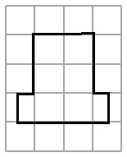
5. Example: Multiply the length 3.8 × 2.4 = 9.1. Draw the new length of 9.12 cm. Multiply the width 1.5 cm × 2.4 = 3.6. Draw the new width
of 3.6 cm.
6. 8 7. 0.5 8. x = 3 9. 230 cm 10. 69 cm
Section 4.3
1. Example: Divide 5 ÷ 2 = 2.5. Redraw the square with side lengths of 2.5 cm.
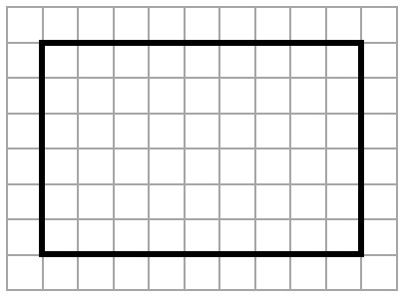
2.

3. 16.4 cm 4. 12.4 km 5. 20
6. a) 156 mm b) 240 cm
7. 52° 8. x = 8; y = 4.5 9. x = 4; y = 9
10. Yes. Example: Each ratio is equal to 1.5.
Section 4.4
1. Reduction 2. 19
3. Example:  ABC is similar to EFG. Similar triangles have corresponding angles equal in measure and corresponding sides proportional in length.
4. AB = DE; AC = DF; BC = EF
5. 3.2 cm 6. 10.2 cm 7. 5.6 cm
8. 25% 9. 17.5 cm 10. 9.5 cm
BLM 4–4 Chapter 4 Problems of the Week
1. In order for the picture to fit completely into the larger size, the width factor, k₁, must be the same as the length factor, k₂. For the rectangles 9 cm × 13 cm and 24 mm × 36 mm:
The factors k₁ and k₂ are not equal; therefore, part of the picture will be cropped.
For the rectangles 10 cm × 15 cm and
24 mm × 36 mm:
The factors are equal; therefore, no part of the picture will be cropped.
3. a) Example:

Side Length of Cube  (cm) | S.A. of Cube  (cm²) | V of Cube  (cm³)
1 | 6 | 3 | 2
2 | 24 | 8 | 3
3 | 54 | 27 | 2
4 | 96 | 64 | 1.5
b) As the size of a cube increases, the surface area (related to heat loss) increases less than volume (related to body size) does. Therefore, large animals lose heat less rapidly than small animals, relative to body size.
4. The diagram shows the inverse square law and its application to distance versus area for similar figures. Example: As the distance between a light source and an object doubles, the area of the similar figure is four times as great. This results in one quarter of the light reaching the object.

BLM 4–5 Section 4.1 Extra Practice
1. a) Example using 0.5-cm grid:
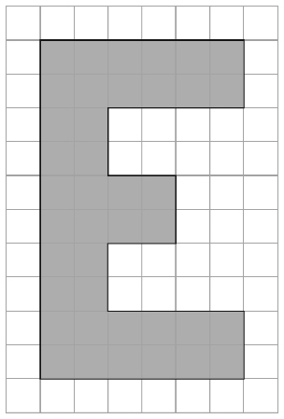
b) Example using 1-cm grid:
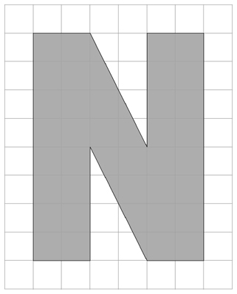
2. Example using 0.5-cm grid:
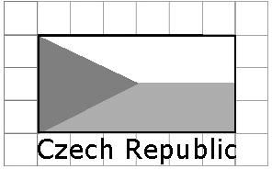
3. a) Example using 0.5-cm grid:
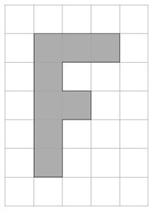
b) Example using 1-cm grid:
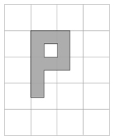
4. Example using 0.5-cm grid:
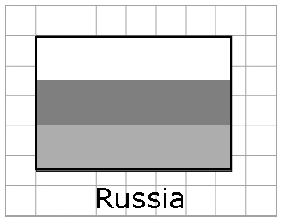
5. Greater than 1. Example: The second image is an enlargement.
6. Example: Check that each dimension of the image is proportionally larger than the original.
BLM 4–7 Section 4.2 Extra Practice
1. a) multiply b) multiply c) divide d) multiply
2. a) 78 b) 1260 c) 34.8 d) 80 e) 86 f) 0.3
3. a) 70 cm b) 9 mm
4. a) 0.5 b) 0.06 c) 0.02 d) 0.25 e) 0.75
f) 0.8
5. 9.4. The scale factor is approximately 9.4.
6. a) 1 cm represents x km. b) 162.5
BLM 4–9 Section 4.3 Extra Practice
1. a) Corresponding angles: ∠E and ∠Q; ∠F and ∠R; ∠D and ∠P. Corresponding sides: DE and PQ; EF and QR; DF and PR.
b) Corresponding angles: ∠N and ∠G; ∠M and ∠H; ∠O and ∠F. Corresponding sides: ON and FG; NM and GH; MO and HF.
2. Yes, the triangles are similar. Look for proof of corresponding angles equal in measure or corresponding sides proportional in length. Example: Corresponding sides proportional in length: = 3; = 3;
= 3
3. a) Example:
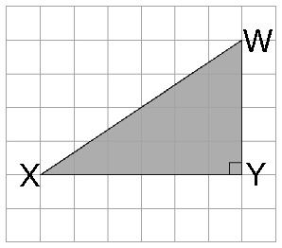
b) Corresponding angles: ∠K and ∠X; ∠L and ∠Y; ∠J and ∠W. Corresponding sides: JK and WX; KL and XY; LJ and YW.
4. = 1.9; = 1.9; ; x = 7.6. The missing side length is 7.6.
5. = 2.5. The ramp is 2.5 m in height.
BLM 4–11 Section 4.4 Extra Practice
1. a) CDEF and RSTU are similar. Example: Corresponding angles are equal in measure:
∠C = 115° and ∠R = 115°; ∠D = 65° and
∠S = 65°.
Corresponding sides are proportional in length: = 1.5; = 1.5. Both conditions for similar polygons have been met.
b) MNOP and WXYZ are not similar. Example: Corresponding sides are not proportional in length: = 2.2; = 2; = 2; = 2.2. Since both corresponding angles equal in measure and corresponding sides proportional in length are necessary for similar polygons, MNOP and WXYZ are not similar.
2. = 2.1; = 2.1;
= 2.1; x = 3. The missing side
length is 3.

3. a) The scale factor is 8000. The missing lengths of the fencing are shown.
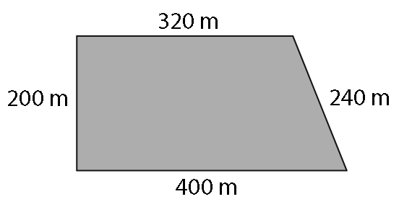
b) 1160 m
BLM 4–13 Chapter 4 Test
1. B 2. C 3. A 4. D
5. 20 6. 5.6
7. Look for an arrow that is 1.5 cm in length.
8. 56.4 m
9. PQR is similar to XYZ. The corresponding sides are proportional with a scale factor of 2: ; ; .
The corresponding angles are equal: ∠X = ∠P
= 90°; ∠Y = ∠Q = 30°; ∠Z = ∠ R = 60°
10. x = 10; y = 11.2

