Section 5.3 Extra Practice
1. Add the polynomials by collecting like terms. Then, simplify.
a) (3x² –2x) + (x² + x) b) (4n² –2n – 4) + (–n² + 5n)
c) (7r – 8) + (3r² – 11) d) (2b² – 8b) + (–2b² + 11b)
e) (7t² – 6t + 9) + (–2t² + 6t – 5) f) (–14k – 10) + (8k –23)
2. Determine the opposite of the expression represented by each diagram. Express the answer in diagrams and symbols.
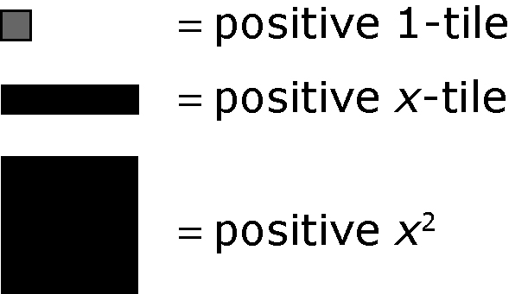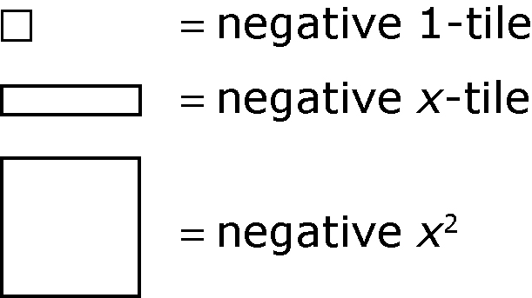

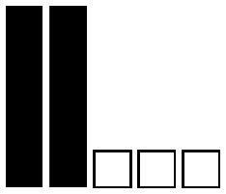

a) b)

3. Determine the opposite of each expression.
a) 6a b) –3c² – 9
c) d² – 8d + 2 d) 6w² + 4w – 0.8
4. Subtract the polynomials by adding the opposite terms, collecting like terms, and then simplifying.
a) (5a – 4) – (3a – 2) b) (7 – 6r) – (3 + r)
c) (6y² – 2y) – (–y² – 3y) d) (8 – 5t) – (–9 – 4t)
e) (h – 1) – (3h² + 7) f) (4k² – 6k + 1) – (–2k² + 5)
5. A triangle has the dimensions shown.
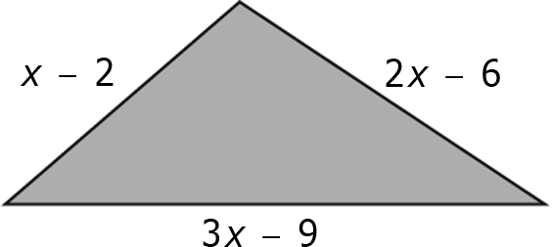

a) Write the unsimplified expression for the perimeter of the triangle.
b) If x = 6, what is the perimeter? Show your work.
c) Simplify the expression in part a) for the perimeter of the triangle. Show your work.
d) Use the simplified expression to verify the perimeter when x = 6. Show your work.

