Section 6.1 Math Link
This worksheet will help you with the Math Link on page 219.

You are in charge of developing a race course for a sailboat race on Lake Diefenbaker, in Saskatchewan. Five classes of sailboats will race on courses that are the same shape, but different lengths.
1. a) Choose one of the following regular polygons for a race course.

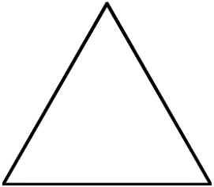


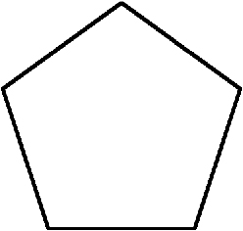

b) Draw and label the five race courses.
• Decide on the length of the sides of the first course. (It must be at least 5 km long.)
• Decide on the length of the sides of the last course. (The longest course must be no longer than 35 km.)
• Decide on the length of the sides of the other courses.
2. Develop a linear relation that describes the race courses.
a) Complete the first two columns in the table of values.

Course Number, n | Course Distance, d (km) | Pattern
Course Number, n | Course Distance, d (km) | Multiply n  by ____  (numerical coefficient) | Add ____  (constant)
1
2
3
4
5

b) Determine the numerical coefficient. Calculate the difference between two consecutive course distances, d. Write this value in the title of the third column. Then, complete the column.
c) Determine the constant. What is the difference between a d-value and the product of the corresponding n-value and the numerical coefficient? Write this value in the title of the last column. Then, complete the column.
d) The equation is d = ______________.

3. a) Develop a problem related to your race courses.
___________________________________________________________
___________________________________________________________
___________________________________________________________

b) Provide the solution.

c) Verify the solution.

