Section 6.2 Extra Practice

1. a) What is the approximate value of d when t = 3? ______
Explain the method you used.
________________________
________________________
________________________
b) What is the approximate value of t when d = 300? ______

2. a) What is the approximate value of y when x = –1.5? ____
b) What is the approximate value of x when y = 10? ____

3. a) What is the approximate value of y when x = 3.5? ____
b) What is the approximate value of x when y = 0.5? ____
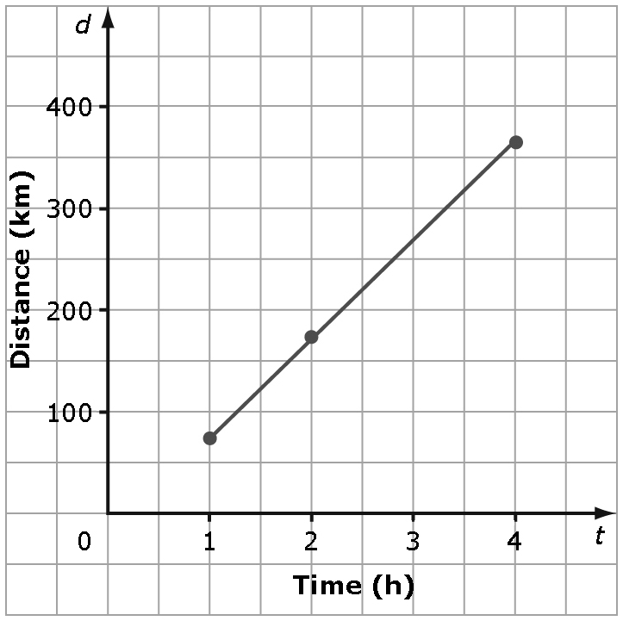

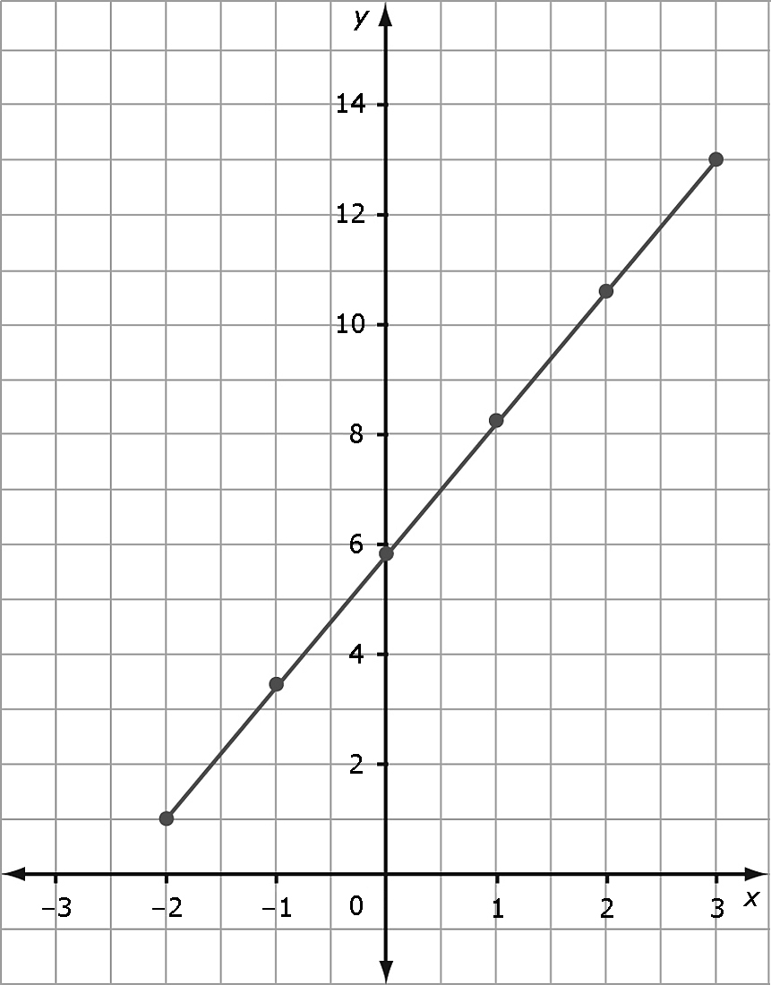
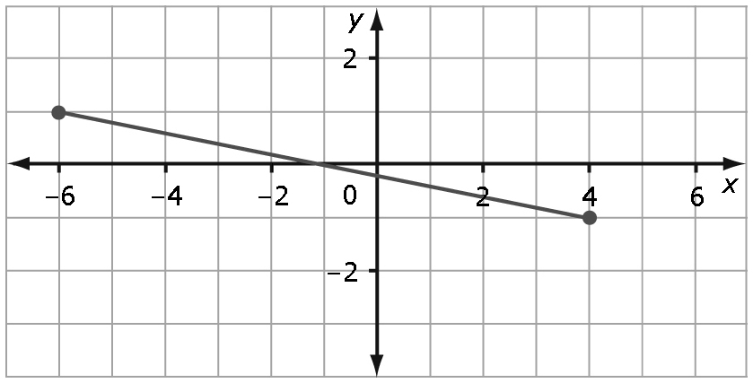

4. a) In the deli section of a grocery store, Greek salad costs $1.50 per 100 g. Plot the data on a graph.
Mass of Greek Salad, m (g) | 100 | 200 | 300 | 400 | 500
Cost, C ($) | 1.50 | 3.00 | 4.50 | 6.00 | 7.50


b) From the graph, determine the cost of 800 g of Greek salad. ______
c) From the graph, determine how much salad you get for $10.50. ______

5. A car rental company charges a flat rate of $35.00 plus $0.45 per kilometre for renting a car. The graph shows the cost of renting a car based on the number of kilometres driven.
a) Is it reasonable to interpolate or extrapolate values on this graph? YES NO Explain.
_________________________
_________________________
_________________________
b) What is the rental cost after
driving 300 km? ______
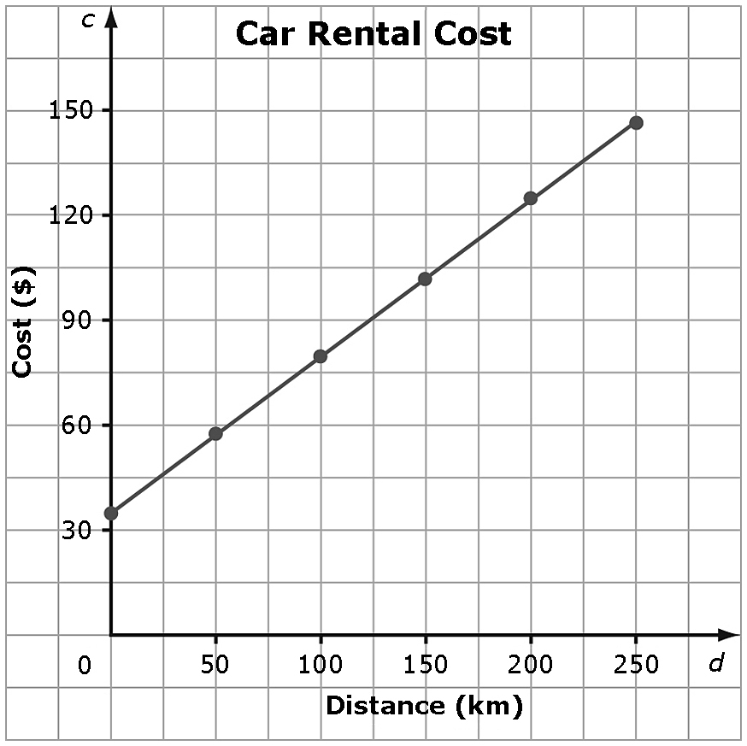

c) Approximately how many kilometres can be driven for a rental cost of
$115? ______

