Section 6.3 Extra Practice
1. Suri drives at an average speed of 90 km/h. The equation relating distance, d, and time, t, is d = 90t.
a) Complete a table of values to represent the relation.
b) Show the relationship on a graph.
c) How long does it take Suri to drive 630 km?
2. For each linear equation, create a table of values and a graph.
a) b = –2a – 15 b) t = –3 c) g = – 2
3. Create a graph and a linear equation to represent each table of values.

 | a) |  | x |  | y
 |  |  | –3 |  | 4
 |  |  | –2 |  | 4
 |  |  | –1 |  | 4
 |  |  | 0 |  | 4
 |  |  | 1 |  | 4
 |  |  | 2 |  | 4
 |  |  | 3 |  | 4
b) |  | a |  | g
 |  | 10 |  | 8
 |  | 11 |  | 8.5
 |  | 12 |  | 9
 |  | 13 |  | 9.5
 |  | 14 |  | 10
 |  | 15 |  | 10.5

c) | t | d
 | 0 | –2.0
 | 1 | –1.75
 | 2 | –1.5
 | 3 | –1.25
 | 4 | –1
 | 5 | –0.75

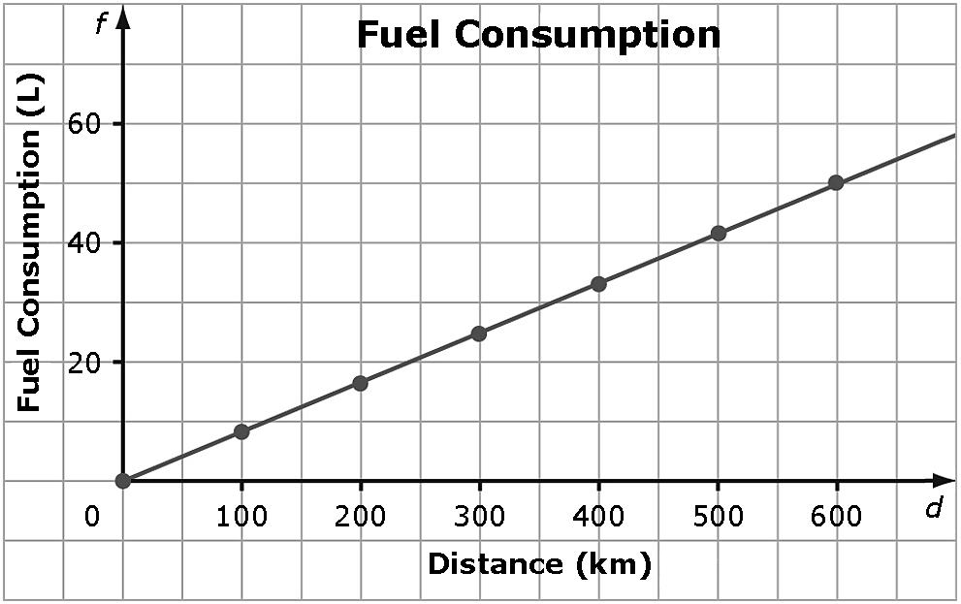
4. The graph shows the relationship
between the fuel consumption, f,
in litres (L), and the distance driven,
d, in kilometres (km).

a) What is the linear equation?
b) How far could you drive with 34 L of gas?
c) Is it appropriate to interpolate or extrapolate values on this graph? What assumption is being made? Explain.

