Chapter 6 Test
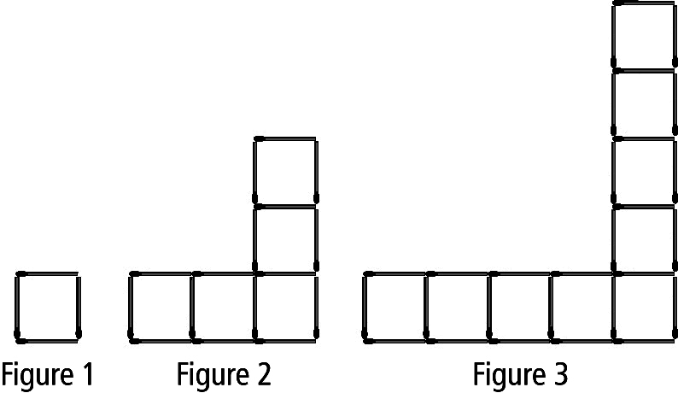
For #1 and 2, select the best answer.
1. Which equation best represents the
relationship between the number of
matches, m, and the figure number, f ?
A m = f + 3 B m = f + 12
C m = 4f – 3 D m = 12f – 8

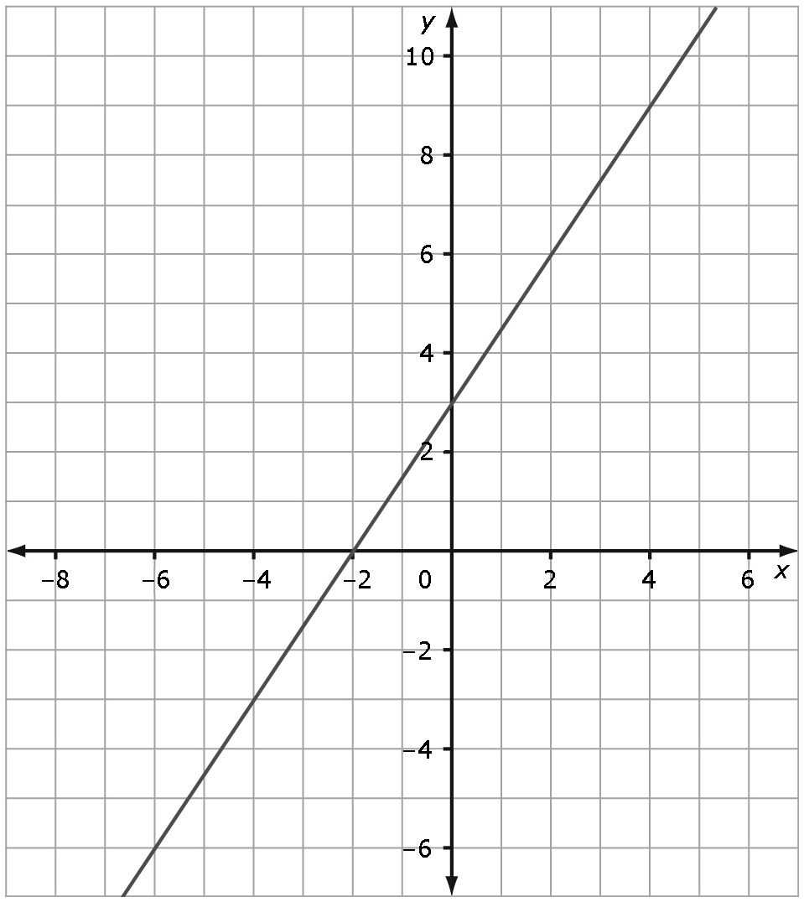
2. Which table of values best represents
this graph of a linear relation?

A | x | y
 | –2 | 0
 | 0 | 3
 | 2 | 6
 | 4 | 9

C | x | y
 | –2 | 0
 | 0 | 3
 | 2 | 9
 | 4 | 27

B | x | y
 | –2 | 0
 | 0 | 3
 | 2 | –6
 | 4 | –9

D | x | y
 | –2 | 0
 | 0 | 3
 | 2 | –9
 | 4 | –27

Complete the statements in #3 and 4, using the graph in #2.
3. When x = 4, the approximate y-coordinate is ____.
4. When y = –6, the approximate x-coordinate is ____.

Short Answer
5. The yearbook committee is pricing the yearbook. The printing company charges a flat fee of $7 per book plus $0.03 per page. Write a linear equation to represent the relationship between the number of pages in the yearbook and its cost.

6. Amanda works as a waitress. She earns $50 a day plus 75% of the tips her customers leave.
(The rest of the tips go to the kitchen staff and bussers.) The table of values represents Amanda’s earnings on different days.
Tips ($) | Total Earnings ($)
20.00 | 65.00
50.00 | 87.50
100.00 | 125.00

a) Write a linear equation that represents the relationship between earnings and tips.
b) Verify the equation.
7. Alex runs at an average speed of 6 km/h. The equation relating distance, d, and time, t, is d = 6t.
a) Graph the linear relation.
b) Use the graph to estimate how long it takes Alex to run 10 km.
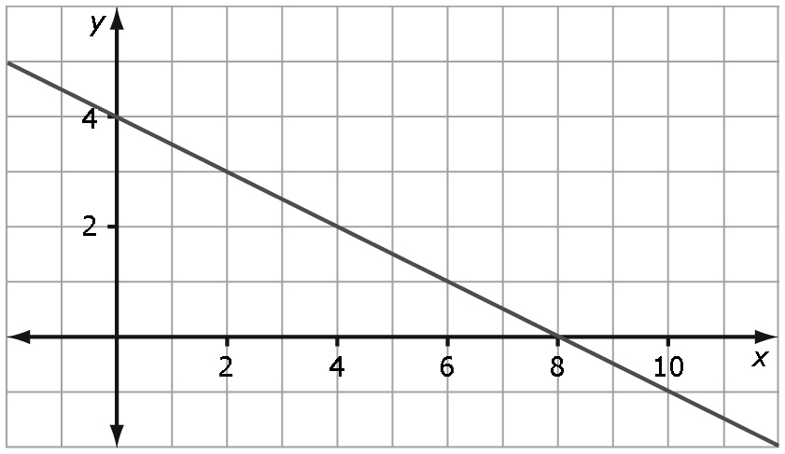
8. Determine the linear relation this graph
represents.

Extended Response
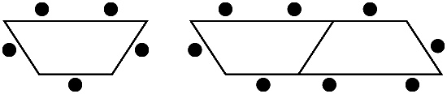
9. Debra plans to set up tables in the
library for orientation day. Each table
can seat five students. The tables can
be connected end to end as shown.
a) Write a linear equation to represent the relationship between the tables and the number of seats.
b) How many students can sit at nine tables?
c) How many tables are needed to seat 50 students?
d) How many tables are required to seat 52 students? Explain your answer.

