Chapter 6 Math Link: Wrap It Up!
This worksheet will help you with the Wrap It Up! on page 247.

You are planning a canoe trip with some friends. Use the Internet, travel brochures, or other sources to find information about your trip.

1. Describe your trip.
• Where are you going?
• How long will your trip be?
• Who is going on the trip? (Include their ages.)

2. You are in charge of ordering food supplies to meet the food energy requirements of your group. For the trip, the amount of food energy required by a canoeist each day can be modelled by the equation a = – 17, where a represents the person’s age and C represents the daily food energy requirement (measured in calories).

a) Create a table of values to help plan the total food energy requirements. For age, use the combined age of all group members.
Number of Days, d
Total Food Energy to Pack, C

Example: Three canoeists
aged 13, 15, and 20 have a combined age of 48 years.
The daily food energy requirement for this group is 6500 calories.
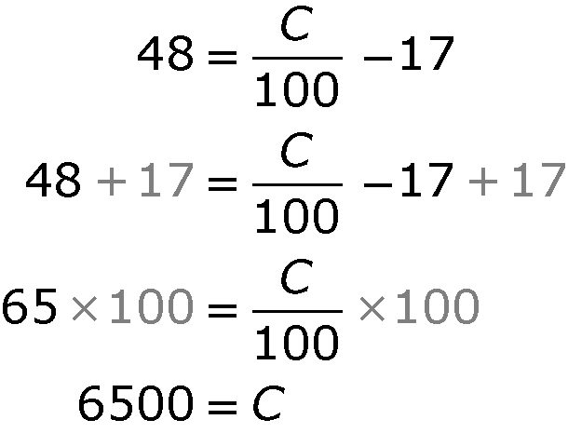

b) Use grid paper to graph the linear relation. Label the graph.

3. a) Develop a problem based on your graph. Your problem needs to include interpolation and extrapolation.
b) Provide a solution. Show your work.

