Chapter 7 Math Link Introduction
This worksheet will help you with the Math Link introduction on page 253.

Gardeners and landscapers are often required to calculate areas when designing a landscape for a backyard, commercial property, or park. When determining how much soil, sand, gravel, mulch, and seed they need for a project, landscape designers also calculate volumes. Here is a landscape design created for a property.

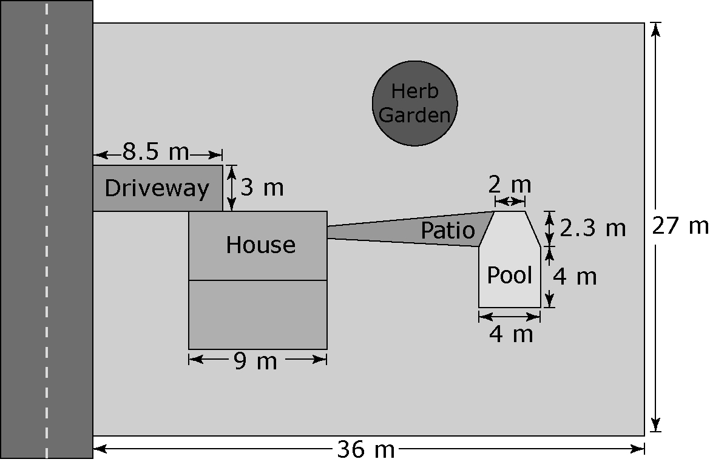

1. The formula for the area of a circle can be written as Area = r ², where r represents radius. Area is measured in square units. The circular herb garden has a radius of 4.5 m. What is the area of the herb garden?

2. Volume is a measurement of how much a shape contains. The formula for volume can be written as Volume = area of base x depth. Volume is measured in cubic units. If the herb garden must have soil that is 0.5 m deep, what volume of soil is needed?

3. What is the difference between the units used to measure the area and the units used to measure the volume of the herb garden?

4. The house is a square. The property is rectangular.
a) Draw the house. Label the length of the sides on your drawing.
b) The formula for the area of a regular four-sided figure is
Area = length x width. Calculate the area of the house in square metres.
c) Calculate the area of the property in square metres.
d) What fraction of the property does the house take up? Express the area of the house as a fraction of the area of the property.

5. The pool is in the shape of a square with a trapezoid attached to it.
a) Draw the pool. Draw a line to divide the pool into two shapes: a square and a trapezoid. Refer to the diagram in the student resource to label all dimensions.
b) What is the area of the square?
c) On your drawing, draw lines to divide the trapezoid into three shapes: a rectangle and two triangles. Label the length of the rectangle. Determine and label the base of each triangle.
d) What is the area of the rectangle?
e) The formula for the area of a triangle can be written as
Area = base x height ÷ 2. What is the area of each triangle?
f) What is the total area of the pool?
g) For the water in the pool to have a depth of 1.7 m, what volume of water is needed?
h) Describe how you calculated the volume.

6. The patio has a surface area of 18 m². It takes 48 paving stones to cover
1 m². An equation can be used to express this relationship: 1 m² = 48.
a) How many paving stones are needed for the patio? Use the above equation to help you.
b) Paving stones are usually rectangular in shape. Look at the shape of the patio. Does your answer in a) need to be exact? Explain.

7. a) What is the total area of the house, pool, driveway, patio, and herb garden?
b) What is the total area of the property that is grass? Explain how you calculated the area.

