Chapter 7 Get Ready
Language of Polynomials

Polynomials are made up of terms that are connected by addition or subtraction. For example, 4x² − 8x + 2 has three terms. Some polynomials have specific names depending on the number of terms that are included:
• A monomial has one term.
• A binomial has two terms.
• A trinomial has three terms.
All expressions with one or more terms are called polynomials.
You can determine the degree of a term by adding the exponents of the variable(s) in the term. Polynomials have a degree the same as the highest degree term. 7b² + 3b − 11 has degree 2 because the highest degree term, 7b², has degree 2.

1. For each expression, state whether it is a monomial, binomial, or trinomial. Then, identify the polynomial degree.
a) x² – 2x + 5 b) 3y² – 9y
c) 11c + 14 d) 24d²

2. Create a polynomial that meets these conditions:
• contains two variables
• has three terms
• is of degree 2

Equivalent Expressions

Like terms differ only by their numerical coefficients. Like terms can be combined. Unlike terms cannot be combined.
Like terms: 3x and –5x can be combined as –2x.
–4k² and 0.5k² can be combined as –3.5k².
Unlike terms: 2t and t² cannot be combined.
–pq and 6p cannot be combined.

3. Which of the following expressions are equivalent to 3n²?
a) 3n + n b) 2n² + n²
c) 4n² – 1 d) –7n² +10n²
4. Simplify by collecting like terms.
a) x² – 6x + 2x² + 5
b) 4p² – 2p + p + 2 – p²
c) –2g² – 7n + 4g² + 3n
d) 17 + s² – 2s² + 5 + 9s – 2

Using a Model to Add and Subtract Polynomials

You can model adding or subtracting polynomials to help simplify the expression.

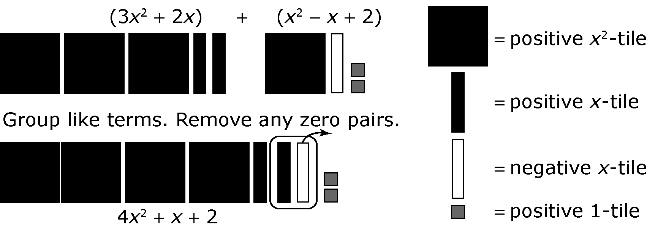

5. Add the polynomials.
a) (5x – 7) + (2x – 3)
b) (–z² – 5z + 2) + (–7z² + 2z)
c) (6m + 6) + (6m – 6)
d) (2t² – 5) + (3t + 6)
6. Subtract the polynomials.
a) (2s – 4) – (2s + 3)
b) (–y² + 3y – 2) – (–2y² – 2y)
c) (4b + 7) − (6b + 8)
d) (–3r² – 5) – (3r – 2)

Using Opposites to Subtract Polynomials

The opposite of a polynomial is found by taking the opposite of each term.
The opposite of 2x² + 3x – 7 is –2x² – 3x + 7.
To subtract polynomials, you can add the opposite.
(4x² + x + 2) – (2x² + 3x –7) = (4x² + x + 2) + (–2x² – 3x +7)
= 4x² – 2x² + x – 3x + 2 + 7
= 2x² – 2x + 9

7. Subtract the polynomials.
a) (5x² + 3x – 7) – (2x² – 5x + 3) b) (2y² + 3y – 3) – (2y² + 4y + 6)
c) (–3r² + 2r + 1) – (–6r² – 8r – 6) d) (–7s² – 13s – 9) – (2s² – 15s – 5)

