Chapter 7 BLM Answers

BLM 7–1 Chapter 7 Math Link Introduction
1. Area = (3.14)(4.5) ² = (3.14)(20.25) =
63.585 m²
2. Volume = 63.585 × 0.5 = 31.7925 m³
3. The units to measure area are square metres and the units to measure volume are cubic metres.
4. a) The diagram should show a square with the side lengths labelled 9 m.
b) Area of house = 9 × 9 = 81 m²
c) Area of property = 36 × 27 = 972 m²
d) =
5. a) The diagram should be similar to the pool in the student resource, with all the labels from the student resource included. A line should divide the pool into a square and a trapezoid.
b) Area of square = 4 × 4 = 16 m²
c) The diagram should show the trapezoid divided into a square and two triangles. The length of the rectangle should be labelled 2.3 m. The base of each triangle should be labelled 1 m.
d) Area of rectangle = 2 × 2.3 = 4.6 m²
e) Area of triangle = 1 × 2.3 ÷ 2 = 1.15 m²
f) Total area of pool = 16 + 4.6 + 1.15 + 1.15 = 22.9 m²
g) 22.9 × 1.7 = 38.93 m³
h) Example: Multiply the total area of the pool by the depth of 1.7 m.
6. a) 18 × 48 = 864 paving stones
b) Example: No, the number of paving stones does not have to be exactly 864 because some will need to be cut to fit the shape of the patio. Also, some paving stones may get broken. Extra paving stones will likely be needed.
7. a) 81 + 22.9 + 25.5 + 18 + 63.585 = 210.985 m² b) 972 – 210.985 = 761.015 m²
Example: Take the total area of the property and subtract the combined area of the house, pool, driveway, patio, and garden.
BLM 7–2 Chapter 7 Get Ready
1. a) trinomial, degree 2 b) binomial, degree 2 c) binomial, degree 1 d) monomial, degree 2
2. Examples: 3x² + 2y − 4x, 3x + 2xy − 4y
3. b) and d)
4. a) 3x² – 6x + 5 b) 3p² – p + 2 c) 2g² – 4n d) –s² + 9s + 20
5. a) 7x – 10 b) –8z² – 3z + 2 c) 12m
d) 2t² + 3t + 1
6. a) –7 b) y² + 5y – 2 c) −2b − 1
d) –3r² – 3r – 3
7. a) 3x² + 8x – 10 b) –y – 9 c) 3r² + 10r + 7 d) –9s² +2s – 4

BLM 7–3 Chapter 7 Warm-Up
Section 7.1
1. y = 2x + 1, where y is the number of lines and x is the figure number.
y = 2(100) + 1. There would be 201 lines in the hundredth figure.
2.
x | y
–4 | 11
–2 | 7
0 | 3
2 | –1
3 | –3
y = –2x + 3
3. Example: Approximately 3.3 kg
4.
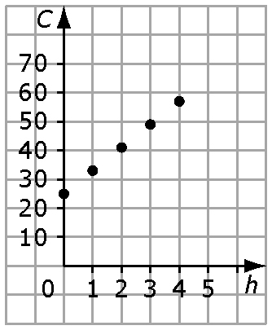
C = 8h + 25, where C is how much you charge, in dollars, and h is the number of hours
5. No. Example: The graph shows y = 10x.
6. 9 7. 8. 6 9. 3⁷ 10. 6³
Section 7.2
1. C = 20 + 0.58n, where C is the total rental charge and n is the number of kilometres
2. The graph should have a y-intercept of 6 and increase from left to right.
3. Shaded tiles are positive, and white tiles are negative.
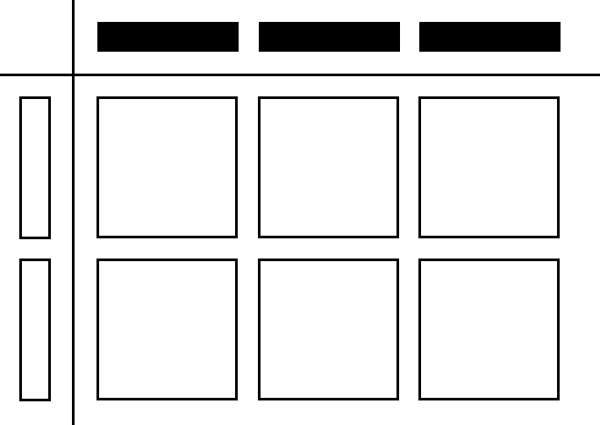
–6x²
4. –21xy 5. –4y 6. 7. 8.4
8. 6x – 15 9. –2x – 10 10. 4(2x + 3)

Section 7.3
1. 3.15xy 2. 9x 3. –x(–x – 3)
4. –6x² – 15xy + 6x 5. –2.1x² + 1.8x
6. 3x + 4 7. –4x + 6y 8. –6y 9. 6 10. –0.8x
BLM 7–4 Chapter 7 Problems of the Week
1. 40 x 9 + (h – 40) x 9 x 1.5, where h is the number of hours Lucy works in a week.
360 + 13.5 (h – 40)
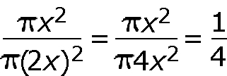
2.

3. a) 365 – 20(7) × n, where n is the number of hens the farmer bought b) Examples: The number of females usually born, the age range during which a hen can lay eggs, the number of chicks allowed to become hens, the number of eggs started with, mortality rates.
4. Length = 2x, height = x, and width = w
(2x)(x)(w) = 12x², w = , w = 6
There are six possible answers:
Example 1:
Length of cargo hold = 25 × 2x = 50x
Width of cargo hold = 10 × 6 = 60
Height of cargo hold = 4 × x = 4x
Example 2:
Length of cargo hold = 10 × 2x = 20x
Width of cargo hold = 25 × 6 = 150
Height of cargo hold = 4 × x = 4x
Example 3:
Length of cargo hold = 10 × 2x = 20x
Width of cargo hold = 4 × 6 = 24
Height of cargo hold = 25 × x = 25x
Example 4: Length of cargo hold= 4 × 2x = 8x
Width of cargo hold = 10 × 6 = 60
Height of cargo hold = 25 × x = 25x
Example 5: Length of cargo hold = 4 × 2x = 80x
Width of cargo hold = 25 × 6 = 150
Height of cargo hold = 10 × x = 10x
Example 6:
Length of cargo hold = 25 × 2x = 50x
Width of cargo hold = 4 × 6 = 24
Height of cargo hold = 10 × x = 10x
Check:
Volume of cargo hold =
(10)(25)(4) × 12x² = 12 000 x²
Example 1: (50x)(60)(4x) = 12 000 x²
Example 2: (20x)(150)(4x) = 12 000 x²
Example 3: (20x)(24)(25x) = 12 000 x²
Example 4: (8x)(60)(25x) = 12 000 x²
Example 5: (80x)(150)(10x) = 12 000 x²
Example 6: (50x)(24)(10x) = 12 000 x²

BLM 7–5 Section 7.1 Extra Practice
1. a) (2x)(–2x) = –4x² b) (2y)(3x) = 6xy
2. Shaded tiles are positive, and white tiles are negative.
a) Example: 6x²

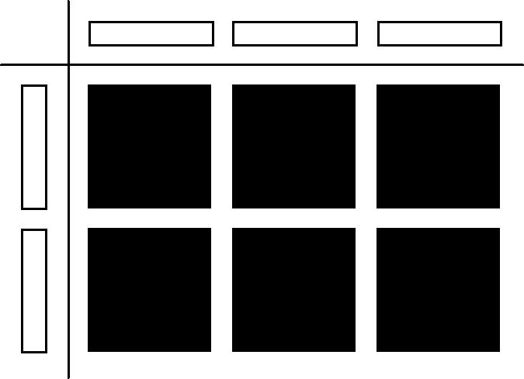
b) Example: 4x²

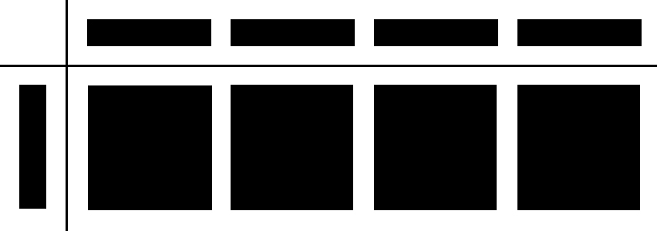
3. a) –8x² b) 21y² c) –15xy
d) –1.2m² e) 8n²
4. a) = 2x b) = –2x
5. a) Example: 2x

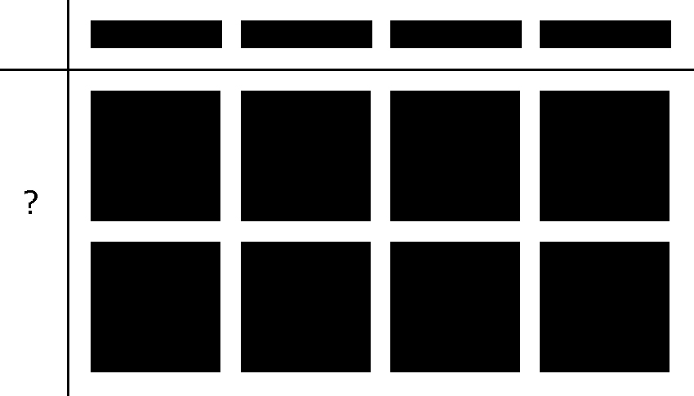

b) Example: 2x

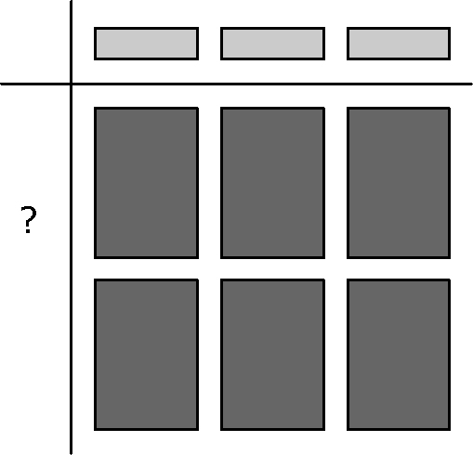

6. a) –2x b) 5x c) 3 d) or e) –7.1m
7. (20.4x²) cm² 8. (3.2x) m
9. Width of lawn = m
Diameter of circle = 4x m, radius = 2x m
Area of circle = (2x)² = 4x² m²
BLM 7–6 Section 7.1 Math Link
1. a) A = l × w
b) Example: Depth = 0.1 m
V = (l × w)0.1 = l × 0.1w
c) Example: Coefficient: 0.1. The depth of dirt is 0.1 m.
2. a) A = r²
b) Example: Depth = 0.2m; V= r² × 0.2 = 0.2 r²
c) Coefficient: 0.2. The depth of water is 0.2 m.
BLM 7-7 Section 7.2 Extra Practice
1. a) (4x)(3x + 5) b) (2.1m + 7)(5m)
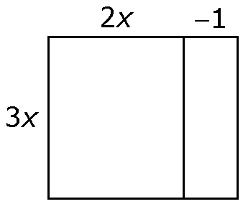
2. a) 6x² – 3x

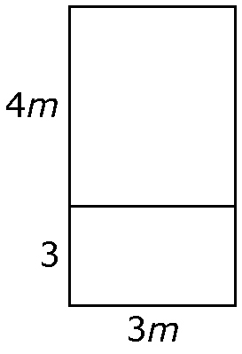
b) 12d²+9d

3. a) (x)(2x + 3) = 2x² + 3x
b) (–2x)(2x – 3) = –4x² + 6x
4. a) 8x² + 2x

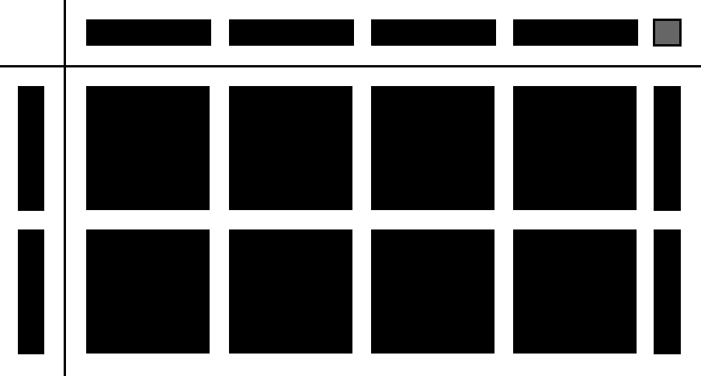

b) –x² – 4x

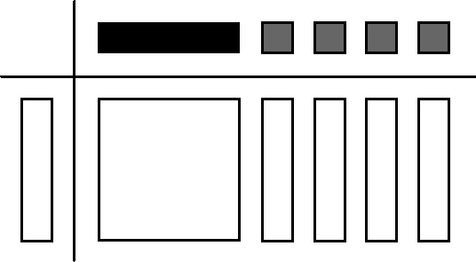

c) 6x² - 2x

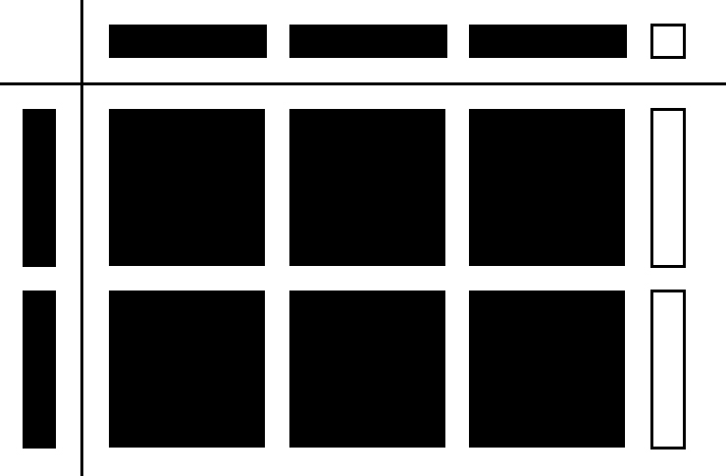
5. a) (5m)(2m) + (5m)(3) = 10m² + 15m
b) (–n)(n) + (–n)(1) = –n² – n
c) (1.3x)(2x) – (1.3x)(5) = 2.6x² – 6.5x
d) (–m)(3m) + (2)(3m) = –3m² + 6m
e) (4.1k)(–3k) – (5.3)(–3k) =
–12.3k² + 15.9k
6. a) 12m² + 3m b) –8x² + 12x
c) 8.4n² – 29.4n d) –6m² – 36m
e) –8x² + 16x
7. a) Area = (5x)(5x + 3) = 25x² + 15x
b) The area of the cement pad is 130 m².
BLM 7-8 Section 7.2 Math Link
1. a) 2w + 2 b) w
2. A = w(2w + 2) = 2w ² + 2w
3. Example: Depth = 0.8 m
V = 0.8(2w ² + 2w) = 1.6w ² + 1.6w
4.
Width(m) | Length  (m) | Area  (m²) | Depth(m) | Volume  (m³)
2 | 6 | 12 | 0.8 | 12 × 0.8  = 9.6
3 | 8 | 24 | 0.8 | 24 × 0.8  = 19.2
4 | 10 | 40 | 0.8 | 40 × 0.8  = 32
5 | 12 | 60 | 0.8 | 60 × 0.8  = 48

BLM 7–9 Section 7.3 Extra Practice
1. a) b)
2. a) –3x + 1

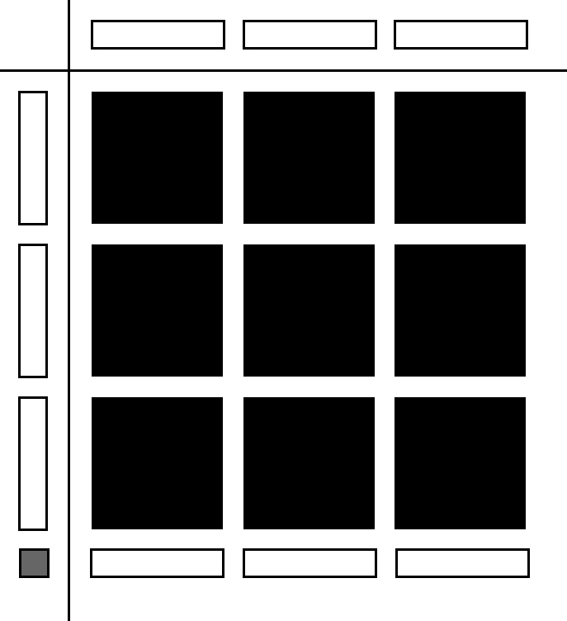

b) 2x + 3

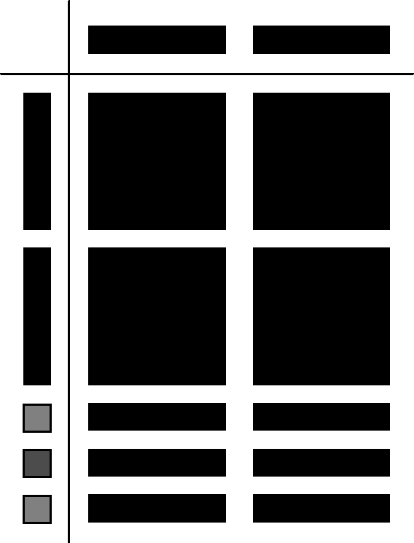
3. a) = 2x – 1 b) = 2y – 3
4. a) –2x + 3

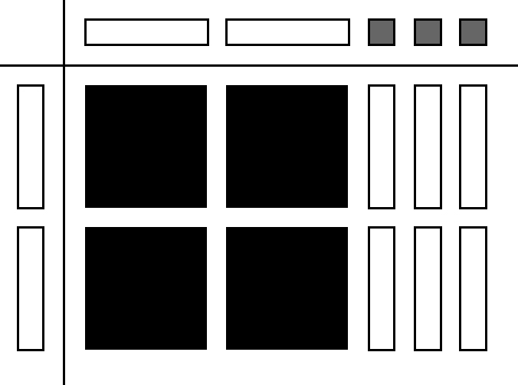

b) 3x + 2y

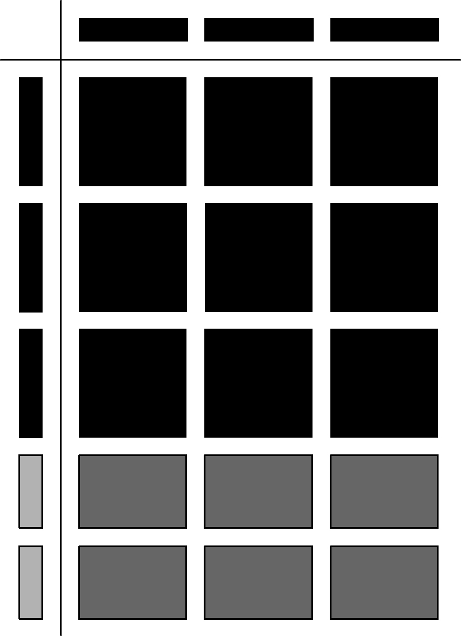
5. a) 3x – 4 b) 4m + 5n
c) 2k – 1 d) –2 – 3n
e) 0.7d + 0.9k – 0.8 f) –3c² +4c – 2
6. You will require (x + 4) pictures to cover the bulletin board.
7. a) Length = = (5x + 15) m
Perimeter = 2(3x) + 2(5x + 15) =
6x + 10x + 30 = 16x + 30.
The perimeter is represented by (16x + 30) m.
b) = 8x + 15
You will require (8x + 15) posts.
BLM 7–10 Section 7.3 Math Link
1. Examples: Parking Lot A: Diagram of 20 m by 25 m parking lot. Parking Lot B: Diagram of 18 m by 15 m parking lot. Dimensions should be labelled.
2. Examples: Parking Lot A: 20 × 25 = 500 m², Parking Lot B: 18 × 15 = 270 m²
3. a) x(x + 4) × 1 = x² + 4x
b) 0.05 m c) = 20x² + 80x
4. a)

Volume for Each Truck Size
Truck Width, x  (m) | Length,  x + 4  (m) | Depth  (m) | Volume of One Truckload  (m³)
1.5 | 1.5 + 4  = 5.5 | 1 | 1.5 × 5.5 × 1  = 8.25
2 | 2 + 4  = 6 | 1 | 2 × 6 × 1  = 12
3 | 3 + 4  = 7 | 1 | 3 × 7 × 1  = 21

b) Example:

 | Area (m²) | Depth (m) | Volume  (m³)
Parking Lot A | 500 | 0.05 | 25
Parking Lot B | 270 | 0.05 | 13.5

c) Example:

Volume  of One Truckload  (m³) | Volume Needed  for  Parking Lot A  (m³) | Number of Truckloads  to Cover Parking  Lot A | Volume Needed  for Parking Lot B  (m³) | Number  of Truckloads to Cover Parking  Lot B
8.25 | 25 | 25 ÷ 8.25  ≈ 3.03 ≈ 4 | 13.5 | 13.5 ÷ 8.25  ≈ 1.6 ≈ 2
12 | 25 | 25 ÷ 12  ≈ 2.08 ≈ 3 | 13.5 | 13.5 ÷ 12  ≈ 1.1 ≈ 2
21 | 25 | 25 ÷ 21  ≈ 1.2 ≈ 2 | 13.5 | 13.5 ÷ 12  ≈ 0.6 ≈ 1
5. Examples: Parking Lot A: The truck with a width of 3 m because it will have to make only one trip and it will have the least amount of extra gravel. Parking Lot B: The truck with a width of 1.5 m because it will have the least amount of extra gravel and it is smaller so it may be more fuel efficient.
BLM 7–11 Chapter 7 Test
1. A 2. D 3. B 4. D
5. –18.87xy 6. 2.5x 7. 4x² – 30x
8. a) 15x² b) 8xy – 10y
9. a) 9x b) –8 + 2x
10. Model should show –4x² + 2x.
11. a) Step 2
b) (5)(7)(x)(x) + (5)(–2)(x) = 35x² – 10x
12. 4x + 1
13. a) 8x² + 28x b) 24x² + 84x c) 2x + 7

BLM 7–12 Chapter 7 Math Link: Wrap It Up!
Example of play area:
1. circle 2. Radius = 7 m 3. 30 cm = 0.3 m
4. Diagram should have all dimensions labelled.
5. Base area = π(7)² ≈ 153.86 m²
6. Volume ≈ 153.86 × 0.3 ≈ 46.16 m³
7. a) radius = r b) Area = πr²
c) Volume = πr² × 0.3 ≈ 0.94r²
Example of swimming pool:
1. parallelogram 2. Base = 18 m; height = 6 m
3. 1.5 m 4. Diagram should have all dimensions labelled. 5. Base area = 18 × 6 = 108 m²
6. Volume 108 × 1.5 ≈ 162 m³
7. a) height = h b) Area = 18h
c) Volume = 18h × 1.5 = 27h
BLM 7–13 Sample Polynomial Puzzle
