Chapter 8 BLM Answers

BLM 8–1 Chapter 8 Math Link Introduction
1 a) 10; 10; 15, so 15 g b) 94; 2h = w,
so 2(47) = 94 c) 25%, or 0.25; ., so s = 320 d) 2p + 1 = b; 2p + 1 = 11, so p = 5 e) ; , so b = 450
f) ; ; 12 = (a + 7), so a = 5
BLM 8–2 Chapter 8 Get Ready
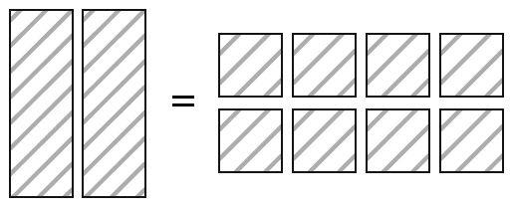
1. a)

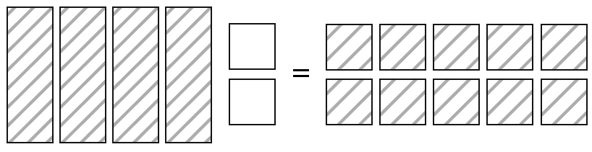
b)

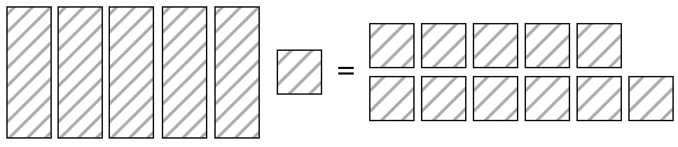
c)

2. a) 2x − 6 = 6 b) 6 = 3x − 9
3. a) 2x + 7 = –3, so x = –5 b) 3x – 4 = 5,
so x = 3
4. a) r = –4 b) s = 6 c) p=–4 d) x = 8
5. a) 5(–4) + 7 = –13, so x = –4 is the solution b) 12 – 5(4) = –8, so x = –4 is not the solution
6. a) x = 7; Check: 7 – 2 = 5 b) t = 2;
Check: 3(2) + 4 = 10 c) g = –2; Check: 2(–2)
– 7 = –11
BLM 8–3 Chapter 8 Warm-Up
Section 8.1
1. 33x² 2. or –1.5x
3. 4. –6x² + 15xy – 21x
5. 2x – 6 6. 7.
8. –0.4 9. 24.96 cm² 10. $34.50

Section 8.2
1. 3x 2. 18x² + 15xy
3. x = or 4. m = 2.9
5. y = 3.125 6. , or
7. or 8. –17.36
9. –28 10. $10.00

Section 8.3
1. or
2. Example: 0.10d = 5, so d = 50.
3. x = 4. 5. x = 32
6. 7. 6x – 15 8.
9. 3 10. –11

Section 8.4
1. a) 2x = b)
2. n = –0.47 3.
4. x = 7 5. $51.50 6. –2x – 16
7. 8. –3x + 5
9. 10. –1.75x + 1
BLM 8–4 Chapter 8 Problems of the Week
1. 10 dimes, 20 nickels, and 80 pennies. Let
x = number of dimes. 10x + 10x + 8x = 280, therefore, x = 10.
2. d = vt, d₁ = v₁t, d₂ = v₂t, v₁t + v₂t = 100, 100t + 50t = 100, 150t = 100. t = 100/150 hours, or 2/3 of an hour, or 40 min. They will meet 40 min after they leave.
3. 4, a, 4 + a, 4 + 2a, 8 + 3a, 12 + 5a, 62
62 = (8 + 3a) + (12 + 5a)
62 = 20 + 8a
42 = 8a
5.25 = a
4. (6751x + 3249y) + (3249x + 6751y)
= 26 751 + 23 249
10 000x + 10 000y = 50 000
x + y = 5
(6751x + 3249y) – (3249x + 6751y)
= 26 751 – 23 249
3502x + (–3502y) = 3502
x – y = 1
x = 1 + y
(1 + y) + y = 5
2y = 4
y = 2
x – 2 = 1
x = 3
Therefore, x = 3 and y = 2.

BLM 8–6 Section 8.1 Extra Practice
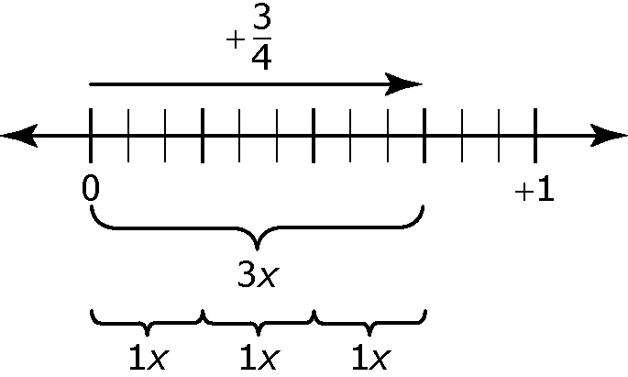
1. a)

The diagram shows that .
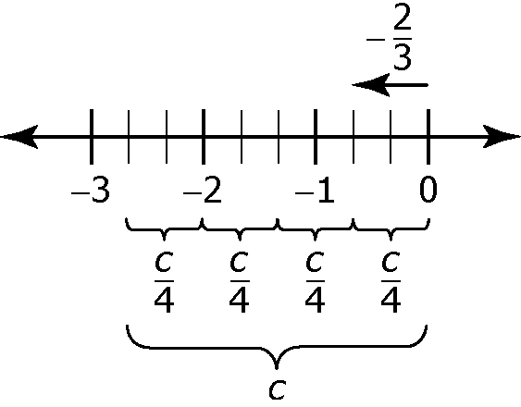
b)

The diagram shows that , or .
2. a) x = 0.2 b) x =
3. a) b) c) x = –0.3
4.
a) x = 1.24
Left Side = –4x Right Side = –4.96
= –4(1.24)
= –4.96
Left side = Right side
b) x = 1.47
Left Side = Right Side = 2.1
=
= 2.1
Left side = Right side
c) m = –15
Left Side = Right Side =
=
=
Left side = Right side
d) x = 17.02
Left side = Right side = 7.4
= 7.4
Left side = Right side

e) m =
Left side = Right side =
=
=
Left side = Right side
f) m = 84
Left side = Right side =
=
=
Left side = Right side
5. a) The bracelet cost $490. b) The canteen earned a $1550 profit. c) The object has a volume of 2.6 L. d) The regular price of the computer was $1150.
BLM 8–7 Section 8.1 Math Link
a) division; f = 1.2 ÷ 3 or f = 0.4 g b) 0.4 g; 0.4n = 12, n = 30 c) I = 0.4n; for eight figs,
I = 0.4(8), I = 3.2 g d) 1.8 = 0.4n, so n = 4.5.
BLM 8–8 Section 8.2 Extra Practice
1. a) x = b) m = –1.75 c) x = 9
2. a) m = ; ; ; ;
b) x = ; ; ;
c) n = –1.02; ;
1.7 + 0.23 = 1.93; 1.93 = 1.93
d) x = 1.54; ;
3.4 + 1.1 = 4.5; 4.5 = 4.5
e) c = ; ;
;
f) x = –58; –9.2 = 0.2(–58) + 2.4;
–9.2 = –11.6 + 2.4; –9.2 = –9.2
3. a) 3x + 13 = 82. The number is 23.
b) 2x – 14 = 42. The blouse was $28.
c) 2x + 1 = 37. The two consecutive numbers are 18 and 19.
d) 27.50x + 215 = 2827.50. They invited 95 people to the banquet. e) 2x + 5.2 = 23.6. Effie cycled 9.2 km and Kirsten cycled 14.4 km.
f) . The down payment is $1410.
BLM 8–9 Section 8.2 Math Link
a) 4r + 0.01 = 0.21 b) 4r = 0.2, so r = 0.05 g.
c) Example:
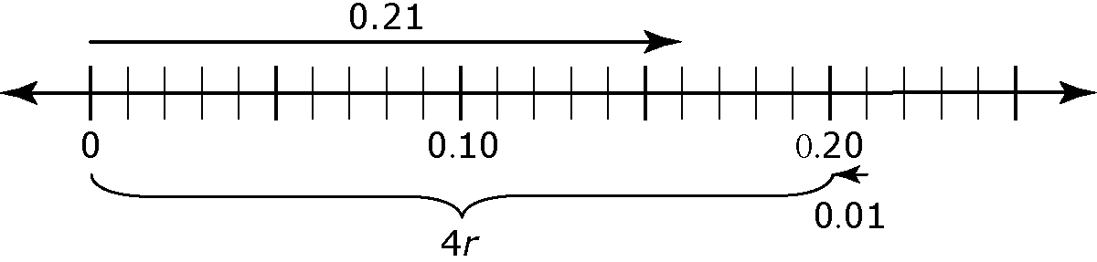
d) Example: The algebraic method because it is quicker.
BLM 8-10 Section 8.3 Extra Practice
1. a) x = 11
Left Side = 3(11 – 5) Right Side = 18
= 33 – 15
= 18
Left side = Right Side
b) x = 4
Left Side = 0.2(4 + 3) Right Side = 1.4
= 0.2(7)
= 1.4
Left side = Right side
c) x =
Left Side = Right Side =
=
=
=
=
Left side = Right side
2. a) The error is that the 0.4 was not distributed into the entire bracket.
0.4(x + 2.2) = 5.4
0.4 x + 0.88 = 5.4
0.4 x = 4.52
x = 11.3
b) The error is that only one side was
multiplied by 5.
x =

x =
x =
3. a) x = 10 b) m = –1.2 c) x = 0.7 d) x = 18 e) x = –4 f) x = $\frac{5}{6}$
4. a) The value of x is 8.2 cm. b) The value of x is 15. c) 50 km/h and 55 km/h
d) The number is 48.
BLM 8–11 Section 8.3 Math Link
a) 0.7 mg (half of the total in two servings)
b) 0.1 mg.
c) c + 0.1 = 0.7
d) c = 0.6 mg
e) Examples: 1.4 = 2(c + 0.1); c = 0.6 mg
BLM 8–12 Section 8.4 Extra Practice
1. a) x = 9.3
Left Side = 0.4(9.3) Right Side = 5.58 – 0.2(9.3)
= 3.72 = 5.58 – 1.86
= 3.72
Left side = Right side
b) x = 8
Left Side = 7.2 + 2.3(8) Right Side = 3.2(8)
= 7.2 + 18.4 = 25.6
= 25.6
Left side = Right side
c) x = –9
Left Side = Right Side =
= =
= = –6
= –6
Left side = Right side
d) m = 14
Left Side = Right Side = 14 + 7
= = 21
= 21
Left side = Right side
e) x = 23
Left Side = Right Side = 10
=
= 10
Left side = Right side

f) m = 5.7
Left Side = 1.4(5.7) Right Side = 1.5(5.7) – 0.57
= 7.98 = 8.55 – 0.57
= 7.98
Left side = Right side

2. a) x = 7
Left Side = Right Side =
= =
= =
=
Left side = Right side
b) x = 36.7
Left Side Right Side
= 1.3(36.7) + 64.2 = 2.7(36.7) + 12.82
= 47.71 + 64.2 = 99.09 + 12.82
= 111.91 = 111.91
Left side = Right side
c) n = 4.5
Left Side = 5(4.5) – 6.4 Right Side = 3(4.5) + 2.6
= 22.5 – 6.4 = 13.5 + 2.6
= 16.1 = 16.1
Left side = Right side
d) n = –42
Left Side = Right Side =
= –21 – 3 =
= –24 = 4 – 28
= – 24
Left side = Right side
e)
Left Side = Right Side =
= =
= =
=
Left side = Right side
f) m = 50
Left Side = 1.2(50) – 17 Right Side = 8 + 0.7(50)
= 60 – 17 = 8 + 35
= 43 = 43
Left side = Right side

3. a) m = –3
Left Side = 5(–3 + 1) Right Side = 2(–3 – 2)
= 5(–2) = 2(–5)
= –10 = –10
Left side = Right side
b) x = 5
Left Side = 0.3[2(5)–1] – 2.3 Right Side = 0.04(5 + 5)
= 0.3(9) – 2.3 = 0.04(10)
= 2.7 – 2.3 = 0.4
= 0.4
Left side = Right side
c) x = –2
Left Side = 10(–2) + 6 Right Side = 4(–2) – 6
= –20 + 6 = –8 – 6
= –14 = –14
Left side = Right side
d) m = 3
Left Side = Right Side =
= =
= = 3
= 3
Left side = Right side
4. a) The dimensions of the garden are 4 m
by 13 m.
b) There were 19 quarters and 11 dimes in the cash register.
c) The employee will need 50 kg of cashews for the mixture.
d) Plane A is travelling at 750 km/h, and Plane B is travelling at 1050 km/h.
BLM 8–13 Section 8.4 Math Link
a) 2.5; m = 2.5m – 0.87 or 2.5m = m + 0.87
b) Any three estimates around the amount of
0.58 mg. For example, students might guess 55 mg or 65 mg. Students might look at the number 0.87 and see that it is close to 90. 90 is about times 60, so they might estimate 60.
c) Example: m = 2.5m – 0.87, m + 0.87 = 2.5m, 0.87 = 1.5m, 0.58 = m. The mass of riboflavin in one small serving of raw almonds is 0.58 mg.
d) Example: Isolating the variable because it was much quicker and more accurate.
BLM 8–14 Chapter 8 Test
1. C 2. D 3. D
4. 13 5. 2.7 6. –200 7.
8. a) 15 b) –9 c) 5.5 d) –12
9. a) 56 + 0.15x = 108.50 b) 350
10. a) Alexandra did not apply the distributive property correctly. This step should be 4x – 20 = 16. b) 9
11. a) b) 51.3 m c) 0.18 s
BLM 8–15 Chapter 8 Math Link: Wrap It Up!
Example: a) One serving of canned salmon contains 0.81 MJ of energy. How many serving would you have to eat to get 3.00 MJ of energy? Let n = number of servings. 0.81n = 3.00 MJ.
b) How many MJ of energy do 8 baked potatoes have? One potato has 0.94 MJ of energy.
Let E = energy. , E = 7.52 MJ
c) A baked potato with some cheddar cheese on it provides a total of 2.08 MJ of energy. How many 45 g servings of cheese is on the potato? Let x = one serving of cheese: 0.76x + 0.94 = 2.08, x = 1.5, or 67.5 g of cheese d) Tinka and Jacob ate a bowl of Brazil nuts. Tinka ate 1.5 servings of the nuts. The total energy of the nuts in the bowl was 8.12 MJ. How many servings did Jacob eat? One serving of nuts is 2.03 MJ. Let j = serving Jacob ate. 2.03(j + 1.5) = 8.12, j = 2.5 servings.
e) Sara ate some cheddar cheese, and Anoop ate some mango. They each ate the same number of servings. The cheese provided Sara with 0.56 MJ more energy than the brazil nuts provided Anoop. How many servings did Sara and Anoop each eat? The energy in one serving of cheddar cheese is 0.76 MJ. The energy in one serving of mango is 0.48 MJ. Let s = the number of servings they
each ate. 0.76s = 0.48s + 0.56, s = 2 servings.

