Chapter 9 Warm-Up
Section 9.1  1. Solve:  2. Solve: 2x – 8 = –15  3. Solve: 3(1.2x – 0.2) = 6.6  4. Solve:  5. Solve:  Section 9.2  1. Solve: 3(x – 3.5) = –2(x + 8)  2. Is 2 the solution to  2.8(2x – 3) = 5 – 1.6x?  Support your answer.  3. Express the inequality, in two different ways.  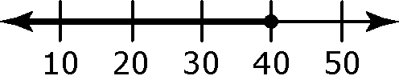  4. Draw a number line for the  inequality x < –3.  5. Describe x > –5 and x ≤ 7 in words.  Section 9.3  1. Verbally and algebraically express the inequality represented by this number line.  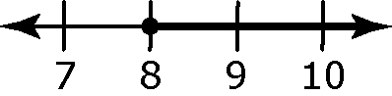  2. Draw the number line that represents the solution to x ≥ 5 and x ≤ 8.  3. Solve the inequality x + 3.5 ≤ 9.6.  State your solution in words.  4. When solving –5x < 35.5, you divide both sides by –5. When you do this,  what happens to the inequality?  5. a) Solve –2x + 8 < –4.  b) Draw a number line to  represent the solutions. | Mental Math  6. Solve: x – 5 = –8  7. Solve: –4x = –36  8. Solve:  9. Solve: y + 3 = –9  10. Solve:  Mental Math  6. Is 3 < 8 a true statement? Support your answer.  7. Is –5 > –8? Explain using a number line.  8. Describe all the integers to the right of  –17 on a number line.  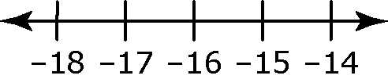  9. Describe the integers that are bold on this number line.  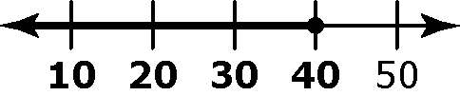  10. Describe the numbers that would make this a true statement: ______ < 8.  Mental Math  6. Solve: –4x – 18 = 22  7. Solve:  8. Solve: 2x = 5x – 24  9. Solve: –3x – 10 = 5x + 38  10. Solve: –2(x – 6) = 4x

