Chapter 9 Test
For #1 to 4, choose the best answer.

1. Mr. Lau asked his class to write an inequality to represent the solution set for the number line below.

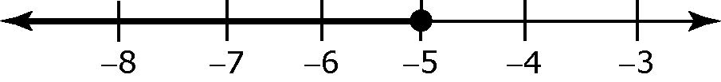 | Erik | x ≤ –5
 | Marissa | x ≥ –5
 | Laurie | –5 ≤ x
 | Steven | –5 ≥ x

Which students correctly represented the solution set given by the graph?
A Erik B Erik and Steven
C Erik, Steven, and Marissa D All four students

2. Students were asked to create a problem where the solution set could be represented graphically by the diagram shown.
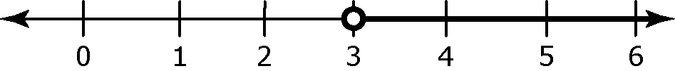

Ronald | A number divided by –2 is greater than –.
Thomas | A number increased by 5, then doubled, is greater than 11.
Jasmine | The minimum value of 4 times a number, decreased by 5, is greater than or equal to 7.
Stephanie | A number multiplied by –6 is less than 18.

Which student correctly wrote a problem with a solution set that could be represented by the given diagram?
A Ronald B Jasmine
C Thomas D Stephanie

3. The solution set for the inequality 3(–2x + 15) < –21 is determined by solving for x. The solution is shown below.
Step 1 3(–2x + 15) < –21
Step 2 –6x + 45 < –21
Step 3 –6x > –66
Step 4 x < 11
Which of the following statements describes the given solution to the inequality?
A An error was made in Step 2. B An error was made in Step 3.
C An error was made in Step 4. D The steps are all correct.

4. Which rational number is a possible value of x for the linear inequality
3x – 3 < –9 – x?
A B C D

Complete the statements in #5 to 7 by inserting the symbol <, >, ≤, or ≥.

5. Given x + 5 ≥ 12, the solution set is x ____ 7.
6. For the inequality 3x – 2 < 12, the solution set is x ____ 5.
7. The solution set for –10 ≤ 5x + 10 is x ____ 4.

Short Answer

8. Your cell phone plan allows you to send up to 200 text messages per month for $5. Write an inequality to represent the number of text messages you can send for $5 per month.
9. Determine the solution set, in simplest form, for each of the following inequalities.
a) 4(2x – 1) < 16 b) ≥ –
10. Draw a number line to represent the solution set for the linear inequality
3(2 – x) < 14 + x.

Extended Response

11. Victoria is helping her mother plan a lunch for the people attending a calculator workshop. They have been given a budget of $1000 to cover all costs. The cost of food for lunch is $11.50 per person and beverages are $5.75 per person. There is also a $25 charge to rent the room.
a) Write an inequality that represents the number of people, n, that they can give lunch to and stay within the budget.
b) Solve the inequality for the variable n, rounding to two decimal places.
c) Victoria and her mother disagree about the number of people that they can provide lunch for and stay within their budget. Victoria says that they can have 56 people but her mother says 57 people. Who is correct? Show your work.
d) Considering the maximum number of people who can attend the lunch, how much money will be left over from the original $1000?

