Chapter 9 BLM Answers

BLM 9–1 Chapter 9 Math Link Introduction
1. a) Less than or equal to 60
b) Less than or equal to 2160
2. Answers will depend on student research. You may wish to make sure that students provide a list of their sources.
3. a) Examples: The ride cannot handle the weight of more than that number of people. It would take too long to load the ride with more than that number of people.
b) Examples: No standing up while ride is in operation. No food or drink on the ride.
c) No more than four people allowed in each car. p < 4, where p is the number of people in the car
BLM 9–2 Chapter 9 Get Ready
1. a) 5 > 2 b) 7 < 20 c) 5 × 3 d) 9 =
2. a) 4 is less than 8. b) 8 is greater than 2.
c) 14 divided by 2. d) 4 does not equal .
3. a) 5, 4 b) 0, 1 c) 5, 6, 7 d) 3, 2, 1, 0
4. a) 1 < 7, 7 > 1 b) 4 > –1, –1< 4
c) 3 < 3.5, 3.5 > 3 d) 0 < 1, 1 > 0
5. a) 0, 1, 2, 3 b) 5, 6, 7
6. a) x = 2 b) x = −4 c) x = 1
BLM 9–3 Chapter 9 Warm-Up
Section 9.1
1. n = –4.1
2. x = –3.5
3. x = 2.2
4. x = –
5. x = 3
6. Yes. Example: 3 is left of 8 on a number line.
7. No, –5 is further to the right than –8.
Example:
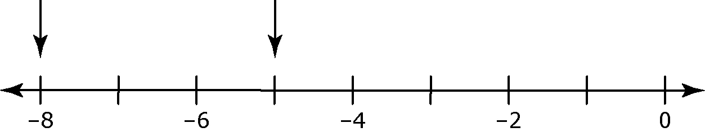

8. Integers that are larger than –17.
9. 40 and all the integers less than 40.
10. All numbers less than 8.
Section 9.2
1. x = –1.1
2. No. The solution is .
3. 40 ≥ x or x ≤ 40
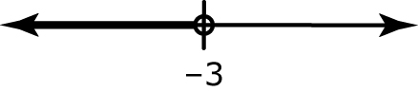
4.

5. Example: All numbers greater than –5 and less than or equal to 7.
6. x = –3
7. x = 9
8. x = –53.56
9. y = –12
10. x = –8
Section 9.3
1. All numbers equal to or greater than 8; x > 8 or 8 < x
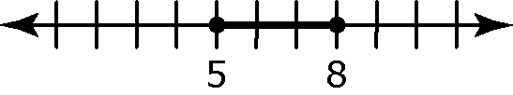
2.

3. All numbers less than or equal to 6.1
4. It reverses.
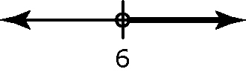
5. a) x > 6 b) Example:

6. x = –10
7. x = 20
8. x = 8
9. x = –6
10. x = 2
BLM 9–4 Chapter 9 Problems of the Week
1. x < 1. If x = 1, the value of is 1. If x > 1, the value of is a fraction, which is less than 1. Therefore, the value of x must be less than 1.
2. No. Example: If a = 0 and c < 0, then
ac > bc.
3. Never. The value approaches 20 but never exceeds it.
4. a) –4x – 2.5 ≤ –10; x = 1.875
b) 2x + 3 < 0.5 − x; x = –1.2
c) –5x + 3.5 = –x + 13.5; x = –2.5

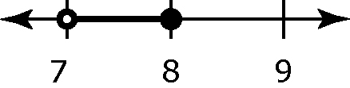
5.

BLM 9–5 Section 9.1 Extra Practice
1. a) m is greater than negative 2.
b) A number is less than –2.
c) A number is greater than –2 and less than or equal to 2.
d) m is greater than or equal to 2.
2. a) False. Example: A closed circle indicates that the boundary point is a possible value.
b) True
c) False. Example: A boundary point is shown on a number line using either an open circle or a closed circle.
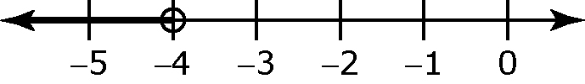
3. b)

c) t < –4, where t is the temperature.
4. a) Example: The temperature of a town that is never warmer than 2 ºC.
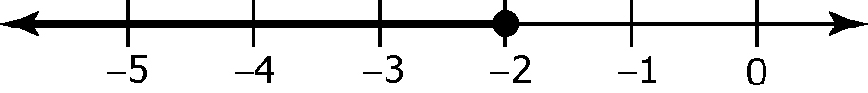
b)

5. a) Example: The number of players for a game that requires more than two people to play.
c) p > 2, where p is the number of players
6. a) Example: The number of people that can fit in a car that seats five.
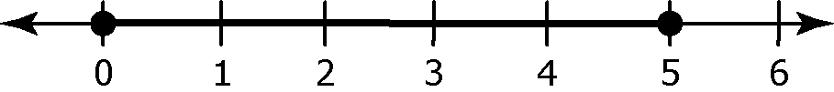
b)

BLM 9–8 Section 9.2 Extra Practice
1. a) –4 or any number less than –4. Examples: –4, –5, –6
b) Any number greater than –3. Examples: –2,
–1, 0
c) Any number between –2 and 5, including –2 and 5: –2, –1, 0, 1, 2, 3, 4, or 5
2. a) x ≤ 7 b) 11 > x or x < 11 c) x ≥ –1.2 d) x < 7.7 e) x ≤ –4 f) x > –13
g) x ≤ –20 h) x ≥ –12
3. a) x > –5 is not correct. b) x ≤ 8 is correct. c) 3 ≥ x is not correct. d) x < 20 is not correct.
e) x ≥ –8 is correct. f) x > –9 is not correct.
4. a) 0.15b ≥ 18, where b is the number of balloons in the package.
b) b ≥ 120
c) The number of balloons in a package is 120 balloons or more.
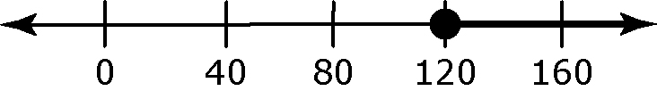
5. a) 5(x + 2) ≤ 25; x ≤ 3 b) The value of x must be greater than –2 or the length of the rectangle would not exist.
BLM 9–10 Section 9.3 Extra Practice
1. Example: Substitute the boundary point to check that both sides are equal.
– 2 ≤ 6
– 2 ≤ 6
8 – 2 ≤ 6
6 ≤ 6

Then, substitute one other number from the solution to determine if it makes
the inequality true.
– 2 ≤ 6
– 2 ≤ 6
–3 – 2 ≤ 6
–5 ≤ 6
2. a) x > 9 b) x < –0.9 c) x ≥ d) x ≥ 5
3. a) x ≤ 2
b) x < 2;
c) x < 5;

d) x ≥ 6;
4. a) x < –5 is correct. b) x ≤ is correct.
5. a) 30n + 200 ≤ 2000 or 200 + 30n ≤ 2000, where n is the number of people
b) 30n + 200 > 20n +400; n > 20
If more than 20 people attend, Beautiful Banquet will be more cost efficient.
6. Let g represent the number of grain bins you build.
75g + 90 > 60g + 120; g > 2
Job B pays more than Job A if you build more than two grain bins each day.
BLM 9–11 Section 9.3 Math Link
1. Total fixed costs ($5000 + $1200 per ride)
= $17 000
Total variable revenues per visitor = $83
2. a) $15 b) $17 000 c) 15v + 17 000, where v is the number of visitors
3. a) $83 b) $2500 c) 83v + 2500
4. a) 83v + 2500 > 15v + 17 000
b) v > 214, to the nearest whole visitor. Justify:
83(214) + 2500 > 15(214) + 17 000
20 262 > 20 210
BLM 9–12 Chapter 9 Test
1. B 2. A 3. D 4. A 5. ≥ 6. < 7. ≥
8. x ≤ 200 9. a) x < 2 b) x ≤ –
10.
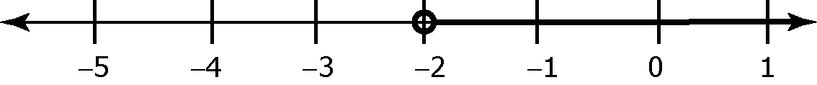
11. a) 11.50n + 5.75n + 25 ≤ 1000
or 17.25n + 25 ≤ 1000 b) n ≤ 56.52
c) 17.25(56) + 25 = 991; 17.25(57) + 25
= 1008.25 Victoria is correct.
d) 1000 – 991 = 9. The money left over will
be $9.

