Chapter 10 Self-Assessment
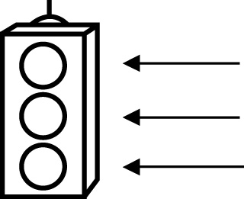 | RED I have not started moving in this area.  YELLOW I am moving along with caution in this area.  GREEN I am moving along confidently in this area.

BEFORE | DURING  (What I can do if I mark yellow or red.) | AFTER  (Proof that I can do this.)
10.1

I can describe the relationship between inscribed angles in
a circle.
I can relate the inscribed angle and central angle
subtended by the
same arc.
10.2
I can describe the relationship between chords and radii of
circles.
10.3
I can relate tangent lines to the radius of the circle.

