Chapter 11 Self-Assessment
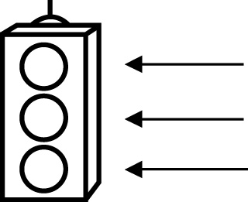 | RED I have not started moving in this area.  YELLOW I am moving along with caution in this area.  GREEN I am moving along confidently in this area.

BEFORE | DURING  (What I can do if I mark yellow or red.) | AFTER  (Proof that I can do this.)
11.1

I can identify how bias may influence the collection of
data.
I can identify how use of language may influence the
collection of data.
I can identify how ethics may influence the collection of
data.
I can identify how cost may influence the collection of
data.
I can identify how
time and timing may influence the
collection of data.
I can identify how privacy may influence the
collection of data.
I can identify how cultural sensitivity may influence the
collection of data.

I can write appropriate survey questions.
I can analyse appropriate survey questions.
11.2
I can identify the difference between a population and a
sample.
I can identify different types of samples.
I can justify using a population for given situations.
I can justify using a sample of a population for given
situations.
I can determine whether results from a sample can be
applied to a
population.
11.3
I can identify assumptions linked to probabilities.
I can explain assumptions linked to probabilities.
I can explain decisions based on probabilities.

11.4
I can develop a research project plan.
I can complete a research project according to a
project plan.
I can collect data.
I can display data.
I can draw conclusions.
I can communicate findings.
I can self-assess a research project by applying a rubric.

