Chapter 1 Self-Assessment
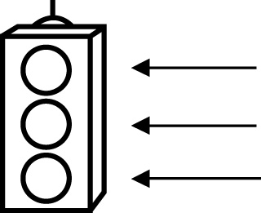 | RED I have not started moving in this area.  YELLOW I am moving along with caution in this area.  GREEN I am moving along confidently in this area.

BEFORE | DURING  (What I can do if I mark yellow or red.) | AFTER  (Proof that I can do this.)
1.1
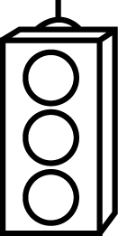
I can classify 2-D shapes or designs according to the
number of lines of
symmetry.
I can identify the line(s) of symmetry for a 2-D shape or
design.
I can complete a shape or design given one half of the
shape and a line of
symmetry.
I can create a design that demonstrates line
symmetry.
1.2
I can tell if 2-D shapes and designs have rotation
symmetry.
I can give the order of rotation for various shapes.
I can give the angle of rotation for various shapes.
I can create designs with rotation symmetry.
I can identify the transformations in shapes and designs
involving line
symmetry.
I can identify the transformations in shapes and designs
involving rotation
symmetry.
1.3
I can determine the area of overlap in composite 3-D
objects.
I can find the surface area for composite 3-D
objects.
I can solve problems involving surface area.

