Chapter 2 Self-Assessment
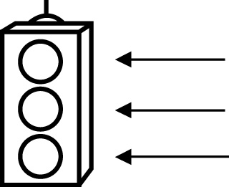 | RED I have not started moving in this area.  YELLOW I am moving along with caution in this area.  GREEN I am moving along confidently in this area.

BEFORE | DURING  (What I can do if I mark yellow or red.) | AFTER  (Proof that I can do this.)
2.1

I can compare and order rational numbers.
I can identify a rational number between two given
rational numbers.
2.2
I can perform operations on rational numbers
in decimal form.
I can solve problems involving rational numbers in decimal
form.
2.3
I can perform operations on rational numbers
in fraction form.
I can solve problems involving rational numbers in fraction
form.

2.4
I can determine the square root of a
perfect square
rational number.
I can determine an approximate square root of a
non-perfect square
rational number.

