Chapter 3 Self-Assessment
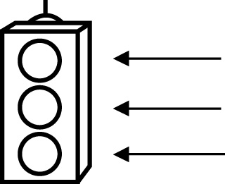 | RED I have not started moving in this area.  YELLOW I am moving along with caution in this area.  GREEN I am moving along confidently in this area.

BEFORE | DURING  (What I can do if I mark yellow or red.) | AFTER  (Proof that I can do this.)
3.1

I can represent repeated multiplication with
exponents.
I can describe how powers represent repeated
multiplication.
I can build models of power.
I can evaluate powers with integral bases (excluding
base 0) and whole
number exponents.
I can evaluate powers that include parentheses.
3.2
I can explain the exponent laws for multiplying powers
with the same base.
I can explain the exponent laws for dividing powers
with the same base.

I can explain the exponent law for raising a power to
an exponent.
I can explain the exponent law for raising a product to
an exponent.
I can explain the exponent law for raising a quotient to
an exponent.
I can explain the exponent law for powers with an
exponent of zero.
I can identify the error in a simplification of an
expression involving
powers.
3.3
I can use the order of operations on expressions with
powers.
I can apply the laws of exponents.
I can determine the sum of two powers.
I can determine the difference of two powers.
I can identify the error in applying the order of operations
in an incorrect
solution.

3.4
I can solve problems by applying the order of operations.
I can solve problems that require combining powers.
I can use powers to solve problems that involve repeated
multiplication.

