Chapter 4 Self-Assessment
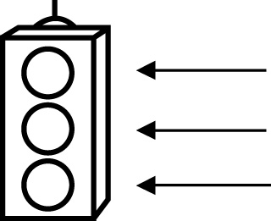 | RED I have not started moving in this area.  YELLOW I am moving along with caution in this area.  GREEN I am moving along confidently in this area.

BEFORE | DURING  (What I can do if I mark yellow or red.) | AFTER  (Proof that I can do this.)
4.1

I can identify enlargements and interpret the scale
factor.
I can identify reductions and interpret the scale
factor.
I can draw enlargements to scale.
I can draw reductions to scale.
4.2
I can identify scale diagrams and interpret the scale
factor.
I can determine the scale factor for scale diagrams.
I can determine if a given diagram is proportional to the
original shape.

4.3
I can determine similar triangles.
I can determine if diagrams are proportional.
I can solve problems using the properties of similar triangles.
4.4
I can identify similar polygons and explain why they are
similar.
I can draw similar polygons.
I can solve problems using the properties of similar polygons.

