Chapter 6 Self-Assessment
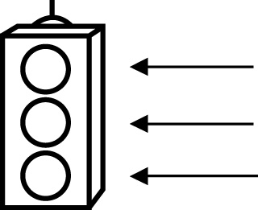 | RED I have not started moving in this area.  YELLOW I am moving along with caution in this area.  GREEN I am moving along confidently in this area.

BEFORE | DURING  (What I can do if I mark yellow or red.) | AFTER  (Proof that I can do this.)
6.1

I can represent pictorial patterns with linear
equations.
I can represent oral patterns with linear
equations.
I can represent written patterns with linear
equations.
I can describe contexts for given linear equations.
I can solve problems that involve pictorial patterns using a
linear equation.
I can solve problems that involve oral patterns using a
linear equation.
I can solve problems that involve written patterns using a
linear equation.
I can verify linear equations by substituting values.

6.2
I can describe patterns found in graphs.
I can extend graphs to determine an unknown value.
I can estimate values between known values on a
graph.
I can estimate values beyond known values on a
graph.
6.3
I can graph linear equations.
I can match equations of linear relations with
graphs.
I can solve problems by graphing a linear relation and
analysing the graph.

