Chapter 7 Self-Assessment
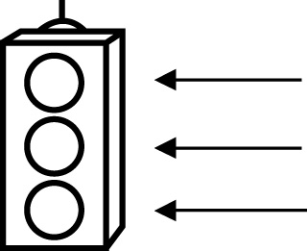 | RED I have not started moving in this area.  YELLOW I am moving along with caution in this area.  GREEN I am moving along confidently in this area.

BEFORE | DURING  (What I can do if I mark yellow or red.) | AFTER  (Proof that I can do this.)
7.1

I can model multiplication of a monomial by a
monomial and
record the process
algebraically.
I can model division of a monomial by a
monomial and
record the process
algebraically.
I can apply a personal strategy for multiplication of a
monomial by a
monomial.
I can apply a personal strategy for division of a
monomial by a
monomial.
7.2
I can model multiplication of a polynomial by a
monomial and
record the process
algebraically.

I can apply a personal strategy for multiplication of a
polynomial by a
monomial.
I can simplify polynomial expressions.
I can identify errors in a simplification of a polynomial
expression.
7.3
I can model division of a polynomial by a
monomial and
record the process
algebraically.
I can apply a personal strategy for division of a
polynomial by a
monomial.
I can simplify polynomial expressions.
I can identify errors in a simplification of a polynomial
expression.

