Chapter 8 Self-Assessment
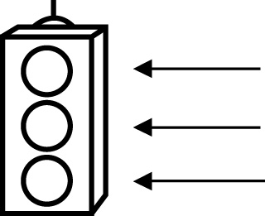 | RED I have not started moving in this area.  YELLOW I am moving along with caution in this area.  GREEN I am moving along confidently in this area.

BEFORE | DURING  (What I can do if I mark yellow or red.) | AFTER  (Proof that I can do this.)
8.1

I can model problems with linear equations that can
be solved using
multiplication.
I can model problems with linear equations that can
be solved using
division.
I can solve linear equations with rational numbers
using multiplication.
I can solve linear equations with rational numbers
using division.
8.2
I can model problems with linear equations involving
two operations.
I can solve linear equations with rational numbers
using two
operations.

8.3
I can model problems with linear equations that
include grouping
symbols on one
side.
I can solve linear equations that
include grouping
symbols on one
side.
8.4
I can model problems with linear equations that
include variables on
both sides.
I can solve linear equations that
include variables on
both sides.

