Chapter 9 Self-Assessment
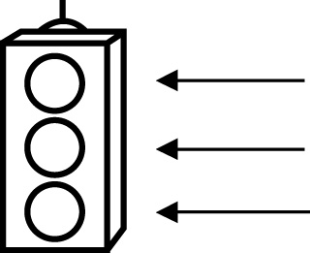 | RED I have not started moving in this area.  YELLOW I am moving along with caution in this area.  GREEN I am moving along confidently in this area.

BEFORE | DURING  (What I can do if I mark yellow or red.) | AFTER  (Proof that I can do this.)
9.1

I can represent single variable linear inequalities verbally.
I can represent single variable linear inequalities
algebraically.
I can represent single variable linear inequalities
graphically.
I can determine if a given number is a possible solution of
a linear inequality.
9.2
I can solve single-step linear inequalities and
verify solutions.
I can compare the processes for solving linear equations and
linear inequalities.
I can compare the solutions of linear equations and
linear inequalities.

I can solve problems involving single-step linear inequalities.
9.3
I can solve multi-step linear inequalities and
verify their
solutions.
I can compare the processes for solving linear equations and
linear inequalities.
I can solve problems involving multi-step linear inequalities.

