Frayer Model
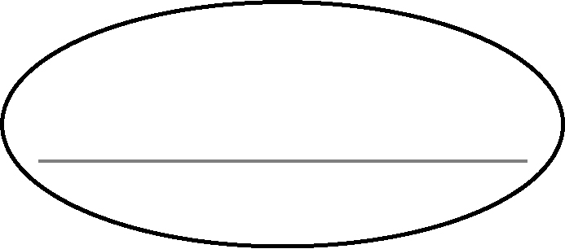  Definition | Facts
Examples | Non-examples

