Chapter 10 Problems of the Week
1. A circle with a spike driven into its centre can be used as a sundial to tell the time based on the shadow of the spike.  a) How many degrees will each hour of the dial occupy?  b) What assumptions are being made?  c) Use mathematical terms to describe the parts of a sundial. | 2. Sam made a toy by attaching a string to a chestnut, spinning it in a vertical orbit, and then letting go. How long should the string be if Sam is 1-m tall and wants to make the chestnut go as high as possible? At what point should the chestnut be released to reach a maximum height? Explain your thinking using the words radius, maximizes, and tangent.
3. If is 3.01 cm and is 7.85 cm, find the area of square WXYZ. Round to the nearest hundredth.  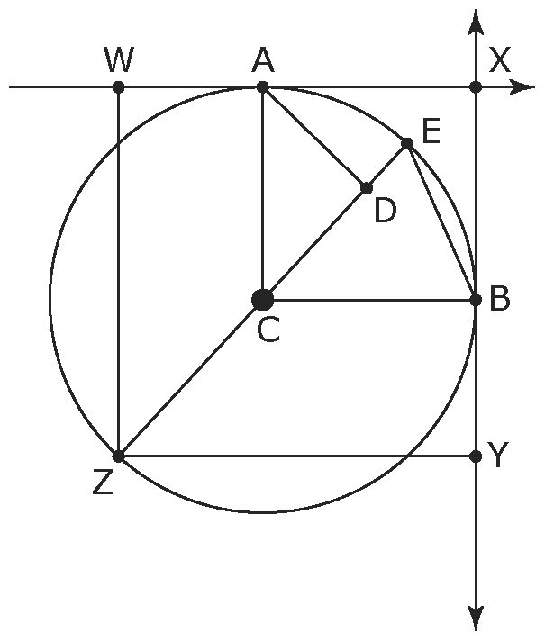 | 4. a) Draw a circle. Place points A and B along the circle so that they form a chord. Place four points, C₁, C₂, C₃, and C₄ on major arcs (larger than a semicircle). Measure ∠AC₁B, ∠AC₂B, ∠AC₃B, and ∠AC₄B. What do you notice? Try this with different-sized circles.  b) Find the centre of one of your circles and call it point X. Measure ∠AXB. What do you notice?

