Chapter 10 Warm-Up

Section 10.1

1. A student draws the following number line for the inequality
x > –1. Is this correct? Why or why not?
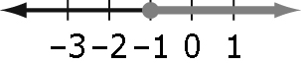
2. Your aunt has children whose ages range between 18 and 25 years of age. Write an inequality to represent their ages.
3. Solve: –5x < –10
4. Draw a number line for the solutions to: 2x – 8 > 15
5. Solve: 3(2x – 1) < 8(x + 1)

Mental Math
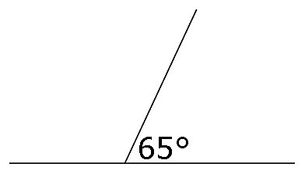
6. Find the measure
of the obtuse angle
on this straight line.

Section 10.2
1. When solving inequalities what happens when both sides of the equation are multiplied by a negative number?
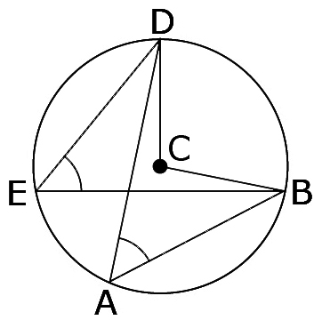
2. Solve: 3(x – 7) < –5x
3. What types of angles
are ∠DCB and ∠DAB
and how are they
related?

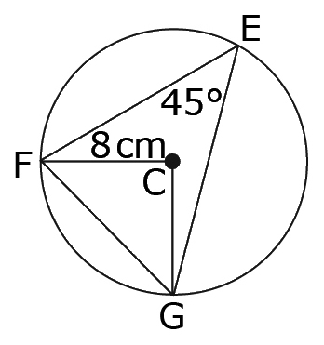
4. What is the measure
of obtuse ∠FCG?

5. Draw an inscribed angle that has a measure of 90° and that is subtended by a chord. Label the centre in your diagram.

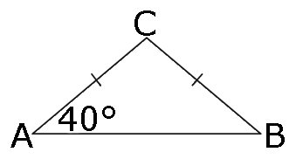
7. All angles in the triangle
add up to 180°. Find the
measure of ∠C.

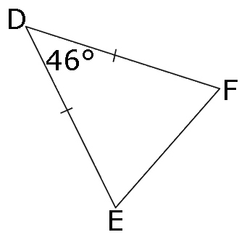
8. In this isosceles triangle,
what is the measure of
∠F?

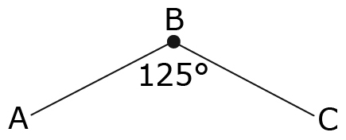
9. What is the measure
of reflex ∠ABC?

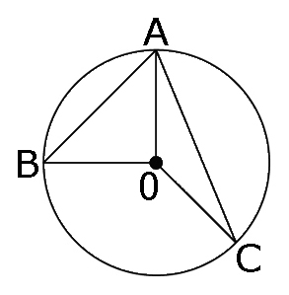
10. Identify all the line
segments that are the
same length in this
diagram.

Mental Math

6. Draw a circle and within the circle draw each of these lengths:
a chord, a diameter, and a radius.
7. Draw a line and label the point A as the midpoint of this line.
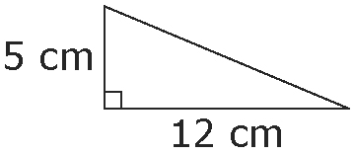
8. Find the missing length
in this right triangle.
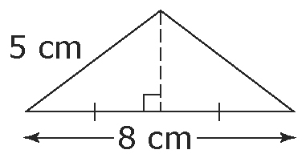
9. Find the height of this
isosceles triangle.

10. Two lines are perpendicular when they meet at 90°. Look around you and name two pairs of objects that are perpendicular to one another.

Section 10.3

1. Find the measure of ∠x and ∠y.
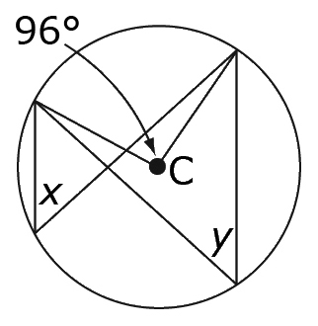
2. Find the measure of ∠x and ∠y.
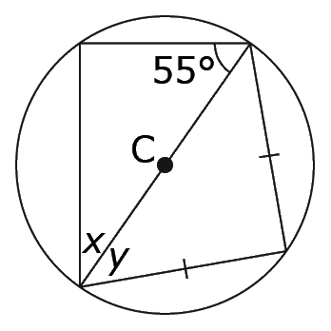
3. Find the measure of ∠x and ∠y.
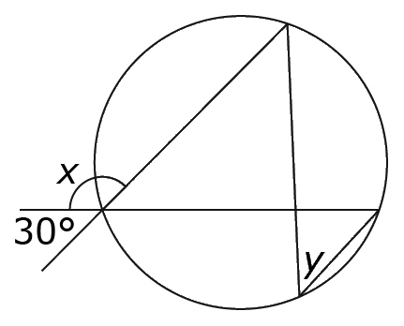
4. If CE = 6 cm and AB = 16 cm, what is the measure of CD?
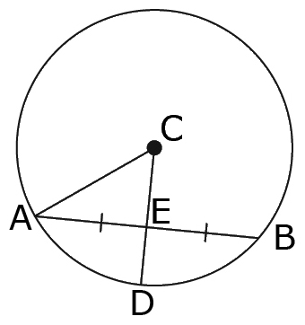
5. Which lengths are perpendicular to each other?
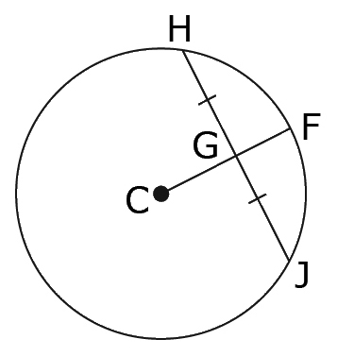

Mental Math

6. An isosceles right triangle has legs measuring 8 cm each. How long is the hypotenuse, to the nearest tenth?
7. A right triangle has a hypotenuse of 25 cm and a leg that measures 20 cm. What is the measure of the second leg?
8. Find the measure of angle x.
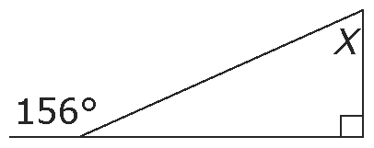
9. Find the measure of all the missing angles in the triangles.
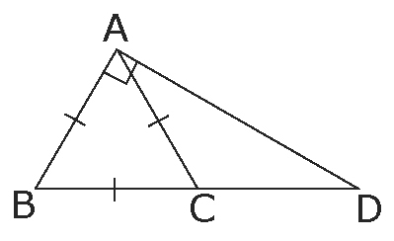

10. Find the measure of each angle in DEF.
