ML9 Chapter 10 Warm-Up Answers

BLM 10–3 Chapter 10 Warm-Up
Section 10.1
1. Incorrect. The circle at –1 should be an open circle.
2. 18 < x < 25 3. x > 2
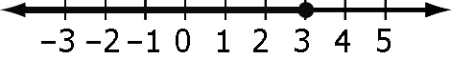
4.

5. x > –5.5 6. 115° 7. 100° 8. 67°
9. 235° 10. A0 = B0 = C0
Section 10.2
1. The inequality reverses. 2. > x
3. ∠DCB and ∠DEB are inscribed angles. They both lie on the same arc so they are both equal to each other.
4. 135°
5. Example:
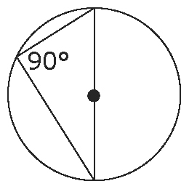
6. Examples will vary.
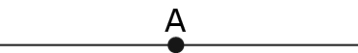
7.

8. 13 cm 9. 3 cm
10. Example: wall and floor
Section 10.3
1. x = 102°; y = 51° 2. x = 42°; y = 45°
3. x = 150°; y = 30° 4. CD = 10 cm
5. Example: HJ ⊥ CF
6. 11.3 cm 7. 15 cm 8. x = 66°
9. ∠ABC = ∠BCA = ∠BAC = 60°
∠CAD = 30°; ∠ACD = 120°; ∠CDA = 30°
10. ∠D = 95°; ∠E = 30°; ∠F = 55°

