ML9 Chapter 11 Warm-Up Answers

BLM 11–3 Chapter 11 Warm-Up
Section 11.1
1. x = 100°; y = 80°
2. AC = 12 cm; AB = BC = 8.5 cm

3. 35° 4. 11.5 m 5. Look for a line that touches the circle at one point but does not pass through the circle. Example:

6. Approximately 98 books
7. Adventure 8. 66.7%
9. No, the data provided does not indicate individual preferences.
10. Example: Yes, the Wong family may prefer other categories. The data collection method may not have allowed the Wongs to choose categories beyond the ones given.
Section 11.2
1. 128° 2. 39°
3. Bias, use of language, ethics, cost, time and timing, privacy, cultural sensitivity
4. Example: The question assumes that customers have a favourite dish. Perhaps, they did not like any dish.
5. Example: What is your favourite academic subject from the list? Circle your choice. (Provide a list of all the academic subjects.)
6. 1% 7. 10% 8. 300
9. A, C, E, G, I, K, M, O, Q, S, U, W, Y
10. B, D, F, H, J, L, N, P, R, T, V, X, Z
Section 11.3
1. Look for an opinion and a supporting point. Example: Halfway through the school year. Students may have forgotten the benefits of homework if they are surveyed during the summer or during exams.
2. Example: Are you in favour of doing homework on a daily basis? If you answered No, what reason best explains why? Circle one. (Provide list of reasons).
3. a) voluntary response sample; convenience
sample b) Example: No, neither sample is random. The results will not likely represent the population.
4. a) systematic sample b) Example: Yes. Students may feel awkward about disclosing their voting preferences.
5. Example: Systematic sample: Choose every fourth student from an ordered list of all students.
6. a) 90 b) $10.01
7. 30% 8. 340 9. 6 10. 1425
Section 11.4
1. Example: Conducting a mail survey about hockey equipment during the summer when people are not playing hockey is costly for a company as people are less likely to respond.
2. Example: The sample could be random if the three names of colleges were randomly drawn from a list of all the names of Canadian colleges.
3. Example: Convenience sample since participants are easily accessible
4. Example: No, the data were collected from one high school. The local university likely draws students from more than one high school.
5. a) 20% b) Example: Each activity has an equal chance of being chosen.
c) Example: Experimental probability because it will give a more accurate reflection of students’ preferences
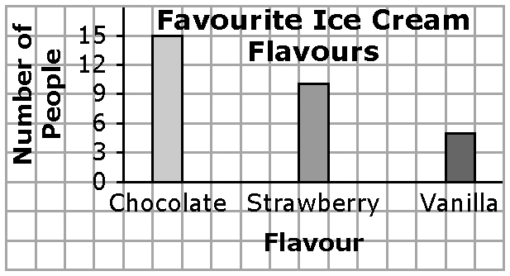
6. Example:

7. Example:
Flavour | Percent
Chocolate | 50%
Strawberry | 33%
Vanilla | 17%
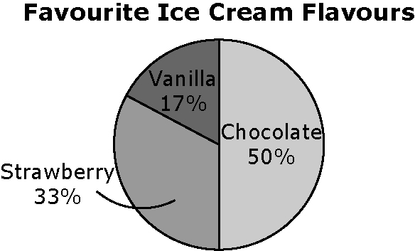
8. Example:

9. Example: No, line graphs are best for showing changes in data over time.
10. Example: Yes, people would not be limited to three flavours and be free to indicate their preference for a different flavour.

