Chapter 1 Problems of the Week
1. Think of regular polygons: equilateral triangle, square, pentagon, hexagon, octagon. Imagine each of them is reflected, translated, or rotated 90°, 180°, or 270° about a point on an axis. Which ones will look like they have not changed their orientation? Assume all shapes start in Quadrant 1. | 2. The perimeter of hexagon ABCDEF is 48 cm. Find the length of line segment AD.  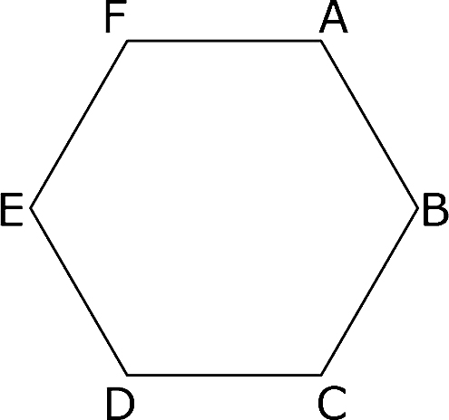
3. A gold-plated sphere is dipped into a measuring container and the water rises 100 mL.  a) If 1 mL equals 1 cm³, what is the surface area of the sphere to the nearest tenth of a centimetre?  b) If the gold plating is 1 mm thick, what is the volume of the gold covering the sphere to the nearest tenth of a cubic centimetre? | 4. Locate images of flowers, starfish, or other natural objects that show rotational symmetry. Create a collage of your images.

