Chapter 1 Warm-Up
Section 1.1

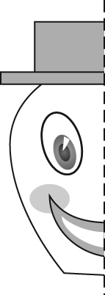
1. To the left of the dotted line
is a design. Draw the design
and its mirror image.

2. On a piece of grid paper, draw a Cartesian grid. Plot the following points: A(–3, 1), B(0, 2), C(–3, –4).
What type of triangle does this make?
3. Copy this shape and translate it two units down and one unit left. What
are the coordinates of A', C' and E'?
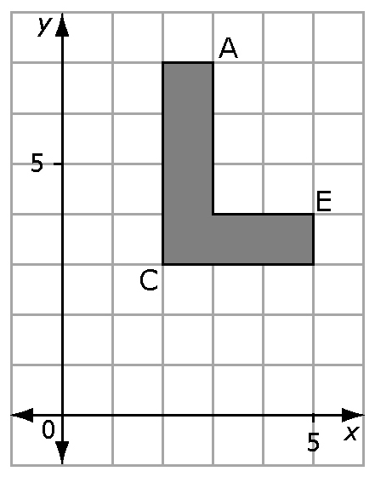
4. In the diagram below ΔDEF is a right triangle that has vertices D(–3, 3),
E(1, 3), F(1, –2). What type of triangle would it be if point F is reflected in the y-axis?
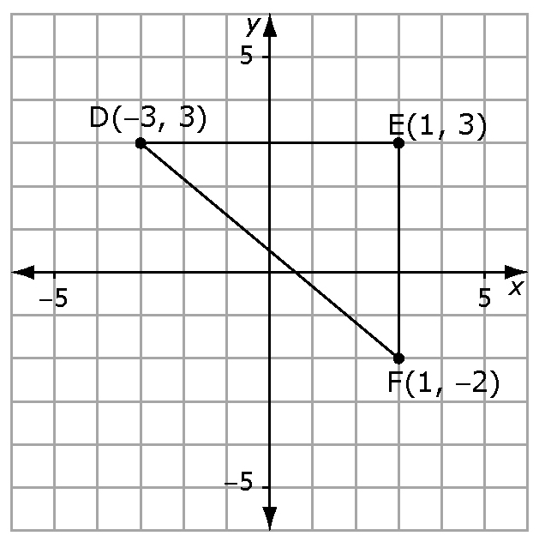

5. The capital letter A has a vertical line of reflection. The image to the right of the line of reflection is the mirror image of the shape on the left. In capital form, what other letters of the English alphabet have a vertical line of reflection?
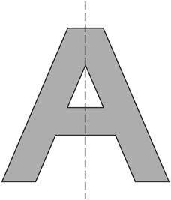

Mental Math
6. Visualize point A(3, 4). Translate it 5 units to the left and one unit up. Identify the location of point A'.
7. Visualize point B(–3, 7). Reflect it over the x-axis. Identify the name and location of the reflected point.
8. Visualize point C(2, –5). Translate it 3 units right and 4 units down. Name and locate the transformed point.
9. Visualize point D(–6, –1) and reflect it over the y-axis. What are the coordinates of the reflected point?
10. Susan takes the point E(2, 8) and reflects it over the x-axis. Then, she takes E' and reflects it over the y-axis. Roberto takes the point E(2, 8) and first reflects it over the
y-axis. Then, he reflects that point over the x-axis. Using grid paper, determine if they will both end up with the same or different answers.

Section 1.2
1. Which capital letters in the English alphabet have both vertical and horizontal lines of symmetry?
2. How many different lines of symmetry does a square have?
3. Using a single line, sketch two different ways to split this figure, so that it is made up of two identical shapes.
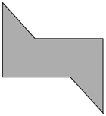
4. A flag is spinning around in a circle and stopping every 90º. Draw all of the positions the flag stops in during one complete turn.
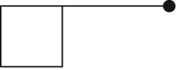
5. The flag in #4 is spinning around in a circle and stopping every 60º. Draw all of the positions the flag stops in during one complete turn.
Section 1.3
1. Use the line of symmetry to complete the figure.
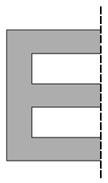
2. Draw an octagon and draw in all its lines of symmetry. How many lines of symmetry can you draw?
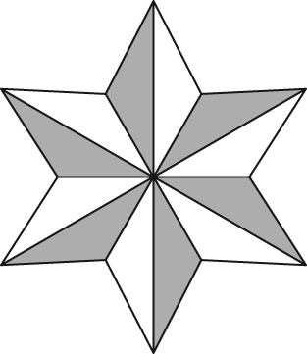
3. What is the order of
rotation of this figure?

4. This shape has rotation symmetry. What is the angle of rotation? Express your answer in degrees and as a fraction of a turn.
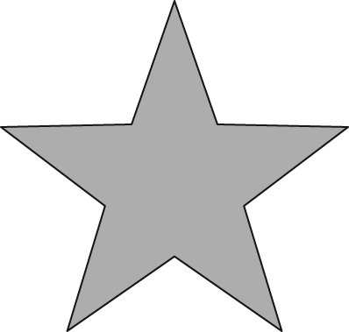
5. Draw a figure that has both line symmetry and rotation symmetry.

Mental Math
6. Divide 360° into eight equal parts. How many degrees are there in each part?
7. If you divide a circle into four equal parts, how many degrees are in each part?
8. How many degrees are in each section of the circle below?
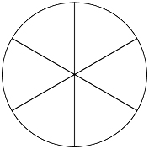
9. Turning through 360° is one complete turn and turning through 180° is half a turn. What fraction of a turn is 120°?
10. What fraction of a turn is 270°?

Mental Math

6. Find the area of the triangle.
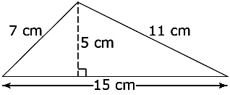
7. Estimate the area of this circle to the nearest whole number.
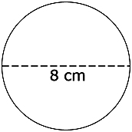
8. Find the missing length using the Pythagorean relationship.
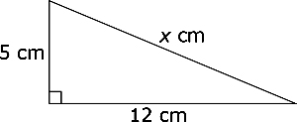
9. What is the length of the height of this triangle?
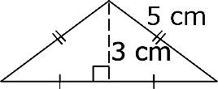
10. What is the diameter of the larger circle?
