ML9 Chapter 1 Warm-Up Answers

BLM 1–4 Chapter 1 Warm-Up
Section 1.1
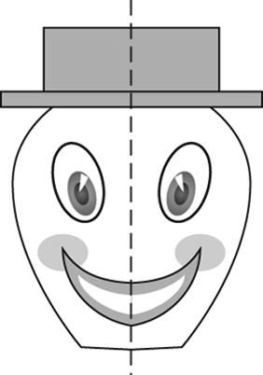
1.

2. Scalene triangle
3. A'(2, 4), C'(1, 0), E'(4, 1)
4. Isosceles
5. A, H, I, M, O, T, U, V, W, X, Y
6. A'(–2, 5) 7. B'(–3, –7)
8. C'(5, –9) 9. D'(6, –1)
10. The same answers
Section 1.2
1. H, I, O, X 2. Four
3. Example:
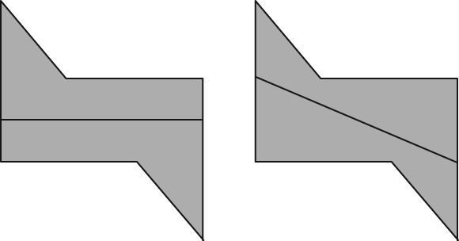
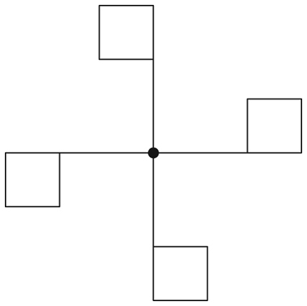
4.

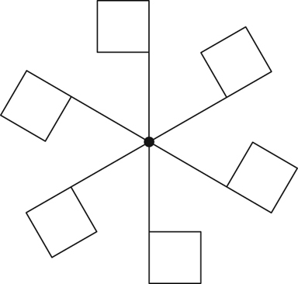
5.

6. 45º 7. 90º 8. 60º
9. One third 10. Three quarters

Section 1.3
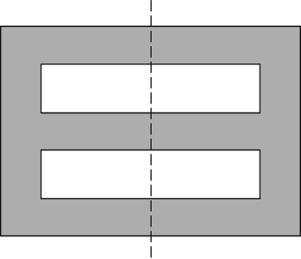
1.

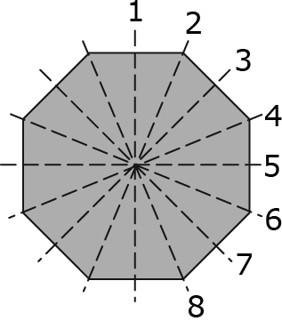
2.

3. Six 4. 72º, of a turn
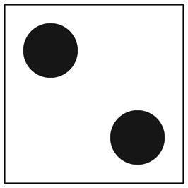
5.

6. A = 37.5 cm² 7. A ≈ 48 cm²
8. 13 cm 9. 8 cm 10. 12 cm

