Chapter 2 Warm-Up

Section 2.1
1. Describe three things in nature that have symmetry.
2. Draw a figure that has a horizontal and a vertical line of symmetry.
3. This figure has rotation symmetry. Determine the order of rotation and the angle of rotation.

4. Find the surface area of the chocolate bar. The ends are equilateral triangles.
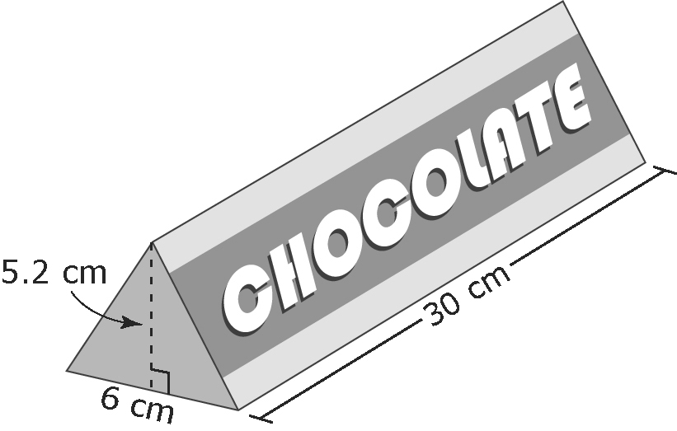
5. Draw the side, top, and front views of this 3-D figure.
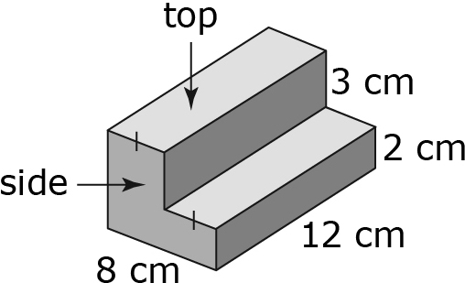

Mental Math
6. Rewrite 0.18 as a fraction in lowest terms.
7. Rewrite in decimal form.
8. Write three equivalent fractions for .
9. Copy the number line and place and –3.7 on it.
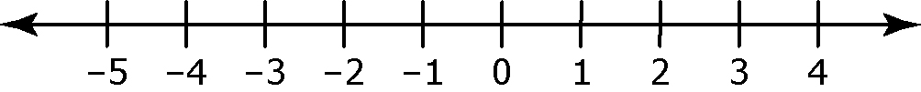
10. Explain why –8 is smaller
than –5.

Section 2.2
1. Is there rotation symmetry in the maple leaf? Explain your answer.

2. The area of your fingertip is approximately 1 cm². If you place your fingertip on a tabletop, how much surface area are you covering: 1 cm² or
2 cm²? Explain your answer.
3. Which is larger: –3.7 or ?
4. Which integers are between and ?
5. Name a rational number between and .
Section 2.3
1. Which is smaller: or ?
2. Determine a rational number that has a denominator of 4 and lies between –2.5 and –3.
3. Estimate the answer to
–2.8[1.7 – (–2.1)].
4. Evaluate
–4.36 + 1.2[2.8 + (–3.5)].
Show each step of your work.
5. The following temperature readings in degrees Celsius are collected over a five-week period: –5, +3, –11, +2, 0. What is the average temperature?

Mental Math
6. Add: –7 + –11
7. Subtract: (–5) – (–8)
8. Multiply: (–10)(–12)
9. Divide: 24 ÷ (–3)
10. Find the average of –8, –12, 6,
–4, and 20.

Mental Math
6. Add:
7. Subtract:
8. Multiply:
9. Divide:
10. You need to sell 36 raffle tickets for a fundraiser. The first week you sell of them, and the second week you sell of the raffle tickets left over from the first week. How many tickets do you have left to sell?

Section 2.4

1. What are and – in decimal form? What is the value of a rational number between these two numbers?
2. Evaluate:
8.2 ÷ (–0.8) – (–0.5)(–0.5)
3. Evaluate: –
4. Rewrite the division statement as a multiplication statement. Then, determine the unknown number.
÷ =
5. Evaluate: +

Mental Math

6. List the next five perfect squares: 1, 4, 9, ...
7. Evaluate:
8. Evaluate: 0.2 × 0.2
9. Estimate the product of
3.9 and 3.9.
10. Find the area of a square with each side length measuring
5 cm.

