Chapter 3 Warm-Up

Section 3.1

1. Order these rational numbers from least to greatest:
, –2.5, , 2.6
2. Calculate:
[2.5(–1.6 – 3.5) + 3.15] ÷ (–2)
3. Evaluate this expression:
4. Determine the quotient: $−\frac{2}{5}÷−3\frac{1}{5}$
5. Evaluate each square root and determine which is smaller: and

Mental Math

6. Find the product:
(–2) × (–2) × (–2) × (–2) × (–2)
7. Evaluate:
(–3) × (–3) × (–3) × (–3)
8. Write the prime factorization of 24.
9. Copy and fill in each box with the same number to make a true statement:
× × = 64
10. You start with one pencil and every day the number of pencils you have doubles. How many pencils do you have after three days?

Section 3.2

1. Find the length of each side of the square, to the nearest tenth.
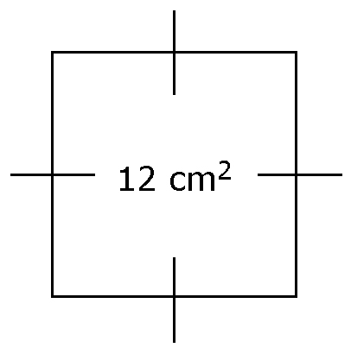
2. Draw a diagram to represent 3².
3. Rewrite (–4)⁶ as a repeated multiplication. Then, evaluate.
4. Evaluate 5¹⁰.
5. Identify the base and exponent of –2⁷.

Mental Math

6. Rewrite 2⁴ × 2³ as repeated multiplication.
7. Rewrite (–5)(–5)(–5)(–5) as a power.
8. Evaluate:
9. Does –2⁴ equal 16 or –16? Explain your answer.
10. Evaluate:

Section 3.3

1. Explain why 2⁴ × 2³ is equal
to 2⁷.
2. Write (–5)³ × (–5) × (–5)² as a single power.
3. Evaluate: 6⁰
4. Rewrite 4¹⁴ ÷ 4⁸ as a single power.
5. Explain why (8³)² is equal to 8⁶.

Mental Math

6. Ana evaluated 5 – 8 + 10.
She arrived at the correct answer of 7. In what order did she evaluate the expression to arrive at this answer?
7. Evaluate: 3(–4 – 7)
8. Where should you place the brackets in the expression 6 ÷ 2 × 5 so that the answer is 0.6?
9. Evaluate: –4(3 + 2) + 7
10. Evaluate: 18 – 10 ÷ (–2)

Section 3.4

1. Identify the power, base, and exponent in .
2. Rewrite (2³)⁴ × 2⁵ as a single power.
3. Evaluate:
4. Insert brackets so that
10 – 12 × (–5) – 3² equals 1.
5. Evaluate:
–5(3)² – 7 × (–2)³ + 5⁰

Mental Math

6. In each ordered pair, (5, 2) and (12, 9), the first number is 3 more than the second number. What are three more ordered pairs that have this relationship?
7. Describe the relationship between the first number and the second number in the table.
First  Number | Second Number
4 | 8
3 | 6
1 | 2

8. What values belong in the blanks?
First  Number | Second Number
1 | 6
4 | 9
5 | 10
21
n
9. Evaluate 2(l + w) if l = 2.4 and w = 1.7.
10. The amount of simple interest, I, you earn on an investment can be found by calculating I = Prt, where P is the principal, in dollars, r is the rate as a decimal value, and t is the time, in years. If you invest $400 in a savings account at 3% interest per year for two years, how much interest will you earn?

