Chapter 4 Warm-Up

Section 4.1
1. What is the base in the expression –4³?
2. Evaluate:
3. Evaluate: (–7)⁵ ÷ (–7) × (–7)³
4. Evaluate: –5² + 3(4)⁰ – 6(3 – 7)
5. Bacteria triple every 4 h. If there are 100 bacteria at noon, how many will there be at midnight on the same day?

Mental Math
6. Determine the product of 2.4 and 1.8.
7. A line measures 6.2 cm in length. What is its length if it is drawn five times longer?
8. What is 15.9 divided by 2?
9. A line measures 3.7 cm in length. What is its length in mm if it is drawn half as long?
10. A line measures 18 cm. It is drawn to measure of its original length. How long is the line now?

Section 4.2
1. Rewrite in exponential form:
[(–5)²]⁴.
2. Evaluate:
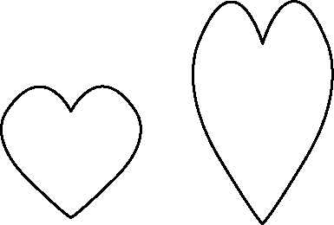
3. Is the second image
an enlargement, a
reduction, or neither
an enlargement nor
a reduction of the
first image? Explain.
4. Draw a reduction of the figure using a scale factor of 0.5.
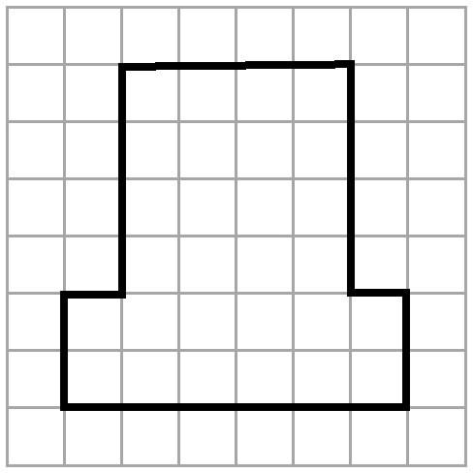

5. Describe how to enlarge this rectangle using a scale factor
of 2.4.
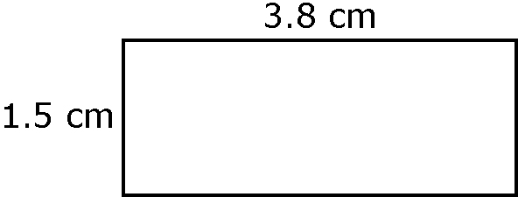

Mental Math
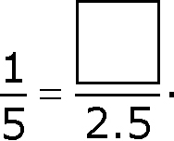
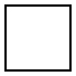
6. What is the missing term in
2 : 3 = : 12?

7. Solve this proportion:
8. Solve for x:
9. Convert 2.3 m to centimetres.
10. Convert 690 mm to centimetres.

Section 4.3
1. A square has side lengths of
5 cm. Describe how you could reduce the square by half.
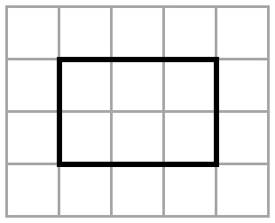
2. Enlarge this figure
using a scale
factor of 3.

3. A vehicle is 8.2 m in length. If you drew it using a scale of
1 : 50, what would be the length of the vehicle on the diagram, in centimetres?
4. A map uses the scale
1 : 100 000. The distance between two cities shown
on the map is 12.4 cm. What is the actual distance between the two cities?

5. An insect measures 2.8 mm in length. A diagram of the insect measures 5.6 cm in length. What is the scale factor?
Mental Math
6. Convert these measurements.
a) 15.6 cm to millimetres
b) 2.4 m to centimetres
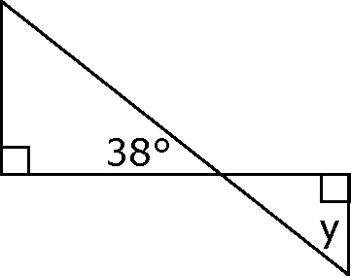
7. Determine ∠y.

8. Solve for x and y:
9. Solve the proportion:
10. Are these ratios equal:?
Show how you know.

Section 4.4
1. Sam is drawing a map of Manitoba. Is the drawing an enlargement or a reduction? Explain.
2. Hannah is 1.52 m tall. If her height on a photo is 8 cm, what is the scale factor of her image?
3. What does  ABC ~ EFG mean?
4. Name the corresponding sides of these two similar triangles.
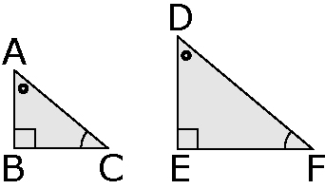

5. Solve for x, to the nearest tenth.
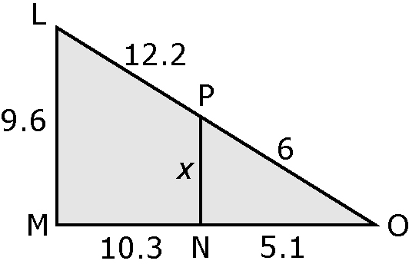

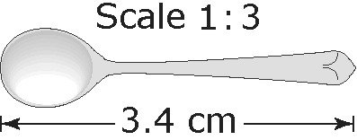
Mental Math
6. What is the actual
length of the spoon?
7. An actual pencil measures
14 cm. Using a scale of 1 : 2.5, what would be the length of a drawing of the pencil?
8. A scale factor of 2 : 1 means that an actual object is drawn 200% larger. If a scale factor is
1 : 4, by what percent is the object in the diagram reduced?
9. A mug is drawn to 40% of its original size. If the height of the mug in the drawing is 7 cm, what is the height of the actual mug?
10. A remote control is 3.8 cm long. If it is drawn 250% larger, what would be its length?

